# What is a Program?

A computer program is a sequence or set of instructions in a programming language for a computer to execute. It is one component of software, which also includes documentation and other intangible components. A computer program in its human-readable form is called source code.

# LAB EXERCISE:

# Write a simple "Hello World" program in two different programming languages of your choice. Compare the structure and syntax.

Here are "Hello World" programs in Python and Java, along with a comparison of their structure and syntax:

Python "Hello World"

**Python**

print("Hello World!")

Java "Hello World"

**Java**

public class HelloWorld {  
 public static void main(String[] args) {  
 System.out.println("Hello World!");  
 }  
}

# THEORY EXERCISE:

# Explain in your own words what a program is and how it functions. What is Programming

A program is a set of instructions that tells a computer what to do, while programming is the process of creating those instructions. Essentially, programming is the act of communicating with a computer in a language it understands to solve a problem or achieve a specific outcome.

Programming, also known as [coding](https://www.google.com/search?cs=1&sca_esv=9ae82e7bfb083ba5&q=coding&sa=X&ved=2ahUKEwiA3cTMwueOAxXzXGwGHad6GjoQxccNegQILRAB&mstk=AUtExfCe4Oze6DeSc7f4UgJW7g8o63t1FeNBpBnzceBnqNEBNEp6wEdwk5kon9akYAiMB--txDc71zAuut_asyGwZV-44gH6zbWxOtqkr7dINoTgDqWugIfYlxpE25UbvNPR1Lc&csui=3), is the act of writing these instructions in a specific language that the computer can understand.

# THEORY EXERCISE:

# What are the key steps involved in the programming process? Types of Programming Languages

The programming process involves several key steps to transform an idea into a functional software application.

***Key Steps in the Programming Process:***

1. **Problem Analysis**
2. **Design**
3. **Coding**
4. **Testing and Debugging**
5. **Documentations**
6. **Deployment and Maintenance**

## Low-Level Languages:

**Machine Language:** This is the most basic level, consisting of binary code (0s and 1s) directly understood by the computer's CPU.

**Assembly Language:** A symbolic representation of machine code, using mnemonics for instructions and addresses. It requires an assembler to translate it into machine language.

## High-Level Languages:

These languages are designed to be more human-readable and abstract, making them easier to write and understand than low-level languages. They require a compiler or interpreter to translate them into machine code. Examples include Python, Java, C++, and JavaScript.

## Other Classifications:

**Compiled Languages:** Translated into machine code before execution (e.g., C++, Java).

**Interpreted Languages:** Executed line by line by an interpreter (e.g., Python, JavaScript).

for structuring and presenting content, not for executing instructions (e.g., HTML, XML).

**Domain-Specific Languages (DSLs):** Designed for a particular application domain (e.g., SQL for database queries).

# THEORY EXERCISE:

# What are the main differences between high-level and low-level programming languages? World Wide Web & How Internet Works

High-level languages prioritize readability, ease of use, and platform independence, while low-level languages offer direct control over hardware resources but are more complex and machine-dependent.

The World Wide Web (WWW or simply the Web) is a system of interconnected documents and resources accessed via the Internet, while the Internet itself is a global network of interconnected computer networks that enables communication and data exchange.

# High-Level Languages:

## Abstraction:

They abstract away the complexities of hardware, making them more portable and easier to understand.

## Human-Readable:

High-level languages use syntax that is closer to human language, making them more readable and maintainable.

## Examples:

Python, Java, C++, and JavaScript are examples of high-level languages.

## Translation:

They require a compiler or interpreter to translate the code into machine code that the computer can understand.

# Low-Level Languages:

## Proximity to Hardware:

They are designed to interact directly with the computer's hardware and memory.

## Machine-Oriented:

Low-level languages are closer to the machine's instruction set and require specific knowledge of the hardware architecture.

## Examples:

Assembly language and machine code are examples of low-level languages.

## Direct Control:

They offer more control over hardware resources and can be more efficient for performance-critical tasks.

# The World Wide Web and the Internet:

## Internet:

The internet is a global network of interconnected computer networks that enables devices to communicate with each other.

## World Wide Web:

The World Wide Web (WWW) is a system of interconnected documents and other web resources that are accessed via the internet.

## Relationship:

The internet provides the infrastructure for the WWW. The WWW is a way of accessing and sharing information over the internet through web browsers and hyperlinks, [according to TechTarget](https://www.techtarget.com/whatis/definition/World-Wide-Web).

# LAB EXERCISE:

# Research and create a diagram of how data is transmitted from a client to a server over the internet.

involves a series of steps, primarily utilizing the TCP/IP protocol suite and breaking down data into packets. The process begins with a client (like a web browser) initiating a request for data. This request is then encapsulated into packets, which are routed across the internet using [IP addresses](https://www.google.com/search?sca_esv=2a5f7f41075773aa&q=IP+addresses&sa=X&ved=2ahUKEwjt8oDmnvGOAxXo4jgGHeFAFiUQxccNegQIIxAB&mstk=AUtExfD-gh61KadsKIvqstT1vUpqfujJeX99UoewjEUR8DcVSHUDLsTuj6PMTAjmhATICE8BGKpE8WBFo0Imqh7oMNEpYj33NxiYc2q4vP-6qZCcPz7kGA6_RMxZlP8k8-rvyiM&csui=3) and managed by [TCP](https://www.google.com/search?sca_esv=2a5f7f41075773aa&q=TCP&sa=X&ved=2ahUKEwjt8oDmnvGOAxXo4jgGHeFAFiUQxccNegQIIxAC&mstk=AUtExfD-gh61KadsKIvqstT1vUpqfujJeX99UoewjEUR8DcVSHUDLsTuj6PMTAjmhATICE8BGKpE8WBFo0Imqh7oMNEpYj33NxiYc2q4vP-6qZCcPz7kGA6_RMxZlP8k8-rvyiM&csui=3) to ensure reliable delivery. The server receives these packets, reassembles them, processes the request, and sends back a response, also in packets, which are routed back to the client.

Here's a more detailed breakdown:

# 1. Client Request:

A user initiates an action, such as typing a URL into a browser, which creates a request for data.

The client's application (e.g., the browser) packages this request into a message.

# 2. [Packetization](https://www.google.com/search?sca_esv=2a5f7f41075773aa&q=Packetization&sa=X&ved=2ahUKEwjt8oDmnvGOAxXo4jgGHeFAFiUQxccNegUIjQEQAg&mstk=AUtExfD-gh61KadsKIvqstT1vUpqfujJeX99UoewjEUR8DcVSHUDLsTuj6PMTAjmhATICE8BGKpE8WBFo0Imqh7oMNEpYj33NxiYc2q4vP-6qZCcPz7kGA6_RMxZlP8k8-rvyiM&csui=3):

The message is broken down into smaller, manageable packets.

Each packet includes header information like the destination IP address and port number, as well as the data payload.

# 3. Routing and Transmission:

The packets are transmitted across the network, potentially passing through multiple routers and switches.

[Routers](https://www.google.com/search?sca_esv=2a5f7f41075773aa&q=Routers&sa=X&ved=2ahUKEwjt8oDmnvGOAxXo4jgGHeFAFiUQxccNegUI0wIQAQ&mstk=AUtExfD-gh61KadsKIvqstT1vUpqfujJeX99UoewjEUR8DcVSHUDLsTuj6PMTAjmhATICE8BGKpE8WBFo0Imqh7oMNEpYj33NxiYc2q4vP-6qZCcPz7kGA6_RMxZlP8k8-rvyiM&csui=3) use IP addresses to forward packets towards their destination.

[Switches](https://www.google.com/search?sca_esv=2a5f7f41075773aa&q=Switches&sa=X&ved=2ahUKEwjt8oDmnvGOAxXo4jgGHeFAFiUQxccNegUIzAIQAQ&mstk=AUtExfD-gh61KadsKIvqstT1vUpqfujJeX99UoewjEUR8DcVSHUDLsTuj6PMTAjmhATICE8BGKpE8WBFo0Imqh7oMNEpYj33NxiYc2q4vP-6qZCcPz7kGA6_RMxZlP8k8-rvyiM&csui=3) use MAC addresses to forward packets within a local network.

# 4. Server Reception and Reassembly:

The server receives the packets.

TCP ensures that all packets arrive, are in the correct order, and that there are no errors.

The server reassembles the packets into the original message.

# 5. Server Processing:

The server processes the request, potentially accessing databases or other resources.

# 6. Server Response:

The server packages the response into packets.

These packets are routed back to the client using a similar process as the initial request.

# 7. Client Reception and Display:

The client receives the response packets.

TCP ensures the packets are reassembled correctly.

The client application (e.g., the browser) then displays the data to the user.

# THEORY EXERCISE:

# the roles of the client and server in web communication. Network Layers on Client and Server

 the client (usually a web browser) initiates requests for resources, while the server (hosting the website) fulfills those requests by providing the requested data or resources. This request-response interaction is fundamental to how the internet works, with clients sending requests and servers responding with either the requested content or error messages.

# Client's Role:

# Initiates Requests:

Clients, like web browsers, send requests to servers for web pages, images, videos, or other resources.

# User Interface:

Clients handle the user interface, allowing users to interact with the web content.

# Interprets Responses:

Clients receive responses from servers and render the content for the user to see.

# Handles Errors:

Clients are responsible for detecting and handling errors that may occur during communication.

# Server's Role:

# Listens for Requests:

Servers continuously listen for incoming requests from clients.

# **Processes Requests:**

Servers process requests, which may involve accessing databases, running computations, or retrieving files.

# Sends Responses:

Servers send back responses to clients, containing the requested data or error messages.

# Manages Resources:

Servers manage resources like data storage, security, and network connections.

# Provides Services:

Servers provide various services, including web hosting, email, file storage, and more.

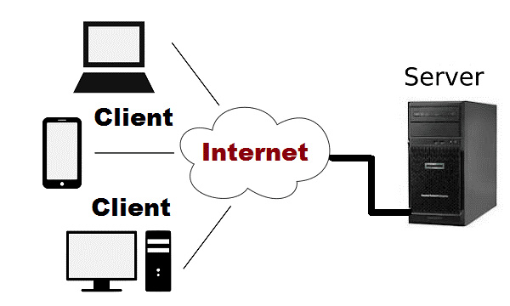

THEORY EXERCISE:

# Explain the function of the TCP/IP model and its layers. Client and Servers

The TCP/IP model, also known as the Internet Protocol Suite, is a framework that defines how devices communicate over a network. It functions by dividing communication into layers, each with specific roles, and relies on the client-

The TCP/IP model is a framework that standardizes how data is transmitted over networks. It divides the communication process into four layers: Network Access, Internet, Transport, and Application. This layered approach simplifies network communication, enabling devices to connect and exchange information reliably.

# TCP/IP Model Layers:

# 1. [Network Access Layer](https://www.google.com/search?cs=1&sca_esv=2a5f7f41075773aa&q=Network+Access+Layer&sa=X&ved=2ahUKEwilodCbnfGOAxXbzjgGHTsCFEkQxccNegQIEBAB&mstk=AUtExfBb3VnTfV5M-Xz3wfIRbcF0vPhniWCrOr1QtaSqFvyADlOh7DRR75y9a5mPE59brX2CR6x51_kwP75YVPKe1yEsB4Mn7XjaGnA4K62r1rRimtGth2D27-9HPbRGK3ZYbrQ&csui=3):

This layer handles the physical and data link aspects of network communication, like how data is transmitted over a specific network medium (e.g., Ethernet, Wi-Fi).

# 2. [**Internet Layer**](https://www.google.com/search?cs=1&sca_esv=2a5f7f41075773aa&q=Internet+Layer&sa=X&ved=2ahUKEwilodCbnfGOAxXbzjgGHTsCFEkQxccNegQIExAB&mstk=AUtExfBb3VnTfV5M-Xz3wfIRbcF0vPhniWCrOr1QtaSqFvyADlOh7DRR75y9a5mPE59brX2CR6x51_kwP75YVPKe1yEsB4Mn7XjaGnA4K62r1rRimtGth2D27-9HPbRGK3ZYbrQ&csui=3):

Responsible for addressing and routing data packets across different networks. The core protocol here is IP (Internet Protocol), which assigns addresses to devices and determines the path for data to travel.

# 3. [**Transport Layer**](https://www.google.com/search?cs=1&sca_esv=2a5f7f41075773aa&q=Transport+Layer&sa=X&ved=2ahUKEwilodCbnfGOAxXbzjgGHTsCFEkQxccNegQIEhAB&mstk=AUtExfBb3VnTfV5M-Xz3wfIRbcF0vPhniWCrOr1QtaSqFvyADlOh7DRR75y9a5mPE59brX2CR6x51_kwP75YVPKe1yEsB4Mn7XjaGnA4K62r1rRimtGth2D27-9HPbRGK3ZYbrQ&csui=3):

This layer ensures reliable end-to-end data transmission. [TCP (Transmission Control Protocol)](https://www.google.com/search?cs=1&sca_esv=2a5f7f41075773aa&q=TCP+%28Transmission+Control+Protocol%29&sa=X&ved=2ahUKEwilodCbnfGOAxXbzjgGHTsCFEkQxccNegQIIRAB&mstk=AUtExfBb3VnTfV5M-Xz3wfIRbcF0vPhniWCrOr1QtaSqFvyADlOh7DRR75y9a5mPE59brX2CR6x51_kwP75YVPKe1yEsB4Mn7XjaGnA4K62r1rRimtGth2D27-9HPbRGK3ZYbrQ&csui=3) provides connection-oriented, reliable communication, while [UDP (User Datagram Protocol)](https://www.google.com/search?cs=1&sca_esv=2a5f7f41075773aa&q=UDP+%28User+Datagram+Protocol%29&sa=X&ved=2ahUKEwilodCbnfGOAxXbzjgGHTsCFEkQxccNegQIIRAC&mstk=AUtExfBb3VnTfV5M-Xz3wfIRbcF0vPhniWCrOr1QtaSqFvyADlOh7DRR75y9a5mPE59brX2CR6x51_kwP75YVPKe1yEsB4Mn7XjaGnA4K62r1rRimtGth2D27-9HPbRGK3ZYbrQ&csui=3) offers connectionless, faster, but less reliable communication.

# 4. [**Application Layer**](https://www.google.com/search?cs=1&sca_esv=2a5f7f41075773aa&q=Application+Layer&sa=X&ved=2ahUKEwilodCbnfGOAxXbzjgGHTsCFEkQxccNegQIERAB&mstk=AUtExfBb3VnTfV5M-Xz3wfIRbcF0vPhniWCrOr1QtaSqFvyADlOh7DRR75y9a5mPE59brX2CR6x51_kwP75YVPKe1yEsB4Mn7XjaGnA4K62r1rRimtGth2D27-9HPbRGK3ZYbrQ&csui=3):

This layer provides network services to applications, such as email (SMTP), web browsing (HTTP), and file transfer (FTP). It's the interface between the user and the network.

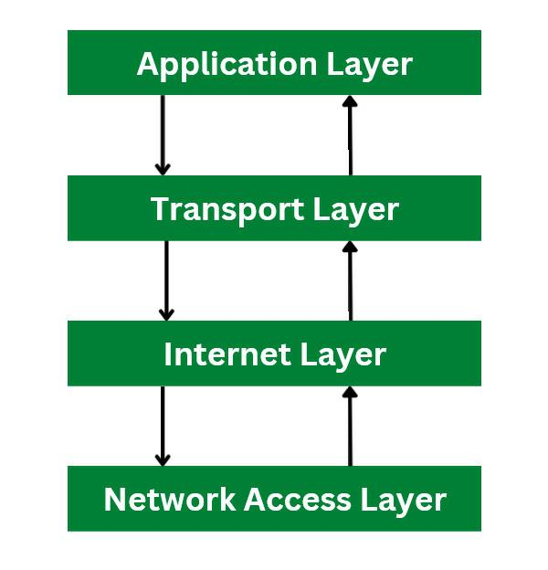

# THEORY EXERCISE:

# Explain Client Server Communication Types of Internet Connections

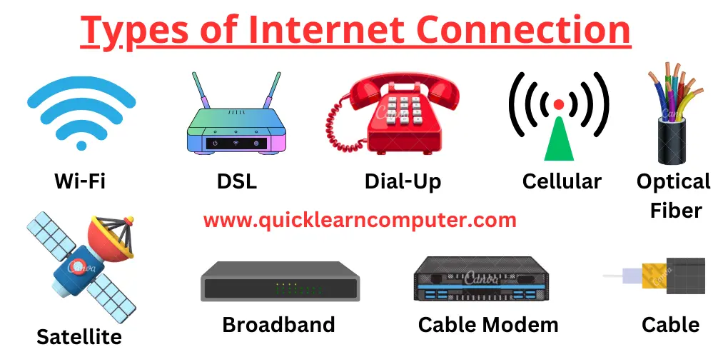

Client-server communication relies on a request-response pattern where clients request services from a server, which then processes the request and returns a response. This communication is typically facilitated by internet connections like DSL, cable, fiber, satellite, or wireless options, each offering varying speeds and technologies.

# Client-Server Communication:

# **Request-Response Model:**

Clients (e.g., web browsers, mobile apps) initiate communication by sending requests to servers.

# Server Processing:

Servers, which host applications and resources, receive these requests, process them, and generate responses.

## Protocols:

Protocols like HTTP, WebSockets, or gRPC are used to structure and manage the exchange of messages between clients and servers.

## Inter-process Communication:

Client-server communication is a form of inter-process communication, where different programs (client and server) exchange information over a network.

## Internet Connection Types:

[**Dial-up**](https://www.google.com/search?cs=1&sca_esv=5493436b52351d30&q=Dial-up&sa=X&ved=2ahUKEwi1u9L_m_GOAxW71DgGHbvjJ_oQxccNegQIMBAB&mstk=AUtExfBiPapNqAO0qwyyXT8yGZ9WsckWHke_Wk8BMlwxL8P9qa0lSBeLBrcFpHM3oK-7hp5iJq52UPzo0FXh5bibCMljFeMCy3XKkOqQovnVyN2zV9RkuJSR1DLN5DqUqd0jpyE&csui=3)**:** Uses a modem and a phone line to connect, offering the slowest speeds.

[**DSL**](https://www.google.com/search?cs=1&sca_esv=5493436b52351d30&q=DSL&sa=X&ved=2ahUKEwi1u9L_m_GOAxW71DgGHbvjJ_oQxccNegQINRAB&mstk=AUtExfBiPapNqAO0qwyyXT8yGZ9WsckWHke_Wk8BMlwxL8P9qa0lSBeLBrcFpHM3oK-7hp5iJq52UPzo0FXh5bibCMljFeMCy3XKkOqQovnVyN2zV9RkuJSR1DLN5DqUqd0jpyE&csui=3)**(Digital Subscriber Line):** Uses existing telephone lines to provide broadband access.

[**Cable**](https://www.google.com/search?cs=1&sca_esv=5493436b52351d30&q=Cable&sa=X&ved=2ahUKEwi1u9L_m_GOAxW71DgGHbvjJ_oQxccNegQIMRAB&mstk=AUtExfBiPapNqAO0qwyyXT8yGZ9WsckWHke_Wk8BMlwxL8P9qa0lSBeLBrcFpHM3oK-7hp5iJq52UPzo0FXh5bibCMljFeMCy3XKkOqQovnVyN2zV9RkuJSR1DLN5DqUqd0jpyE&csui=3)**:** Uses cable television lines to deliver high-speed internet.

[**Fiber Optic**](https://www.google.com/search?cs=1&sca_esv=5493436b52351d30&q=Fiber+Optic&sa=X&ved=2ahUKEwi1u9L_m_GOAxW71DgGHbvjJ_oQxccNegQINBAB&mstk=AUtExfBiPapNqAO0qwyyXT8yGZ9WsckWHke_Wk8BMlwxL8P9qa0lSBeLBrcFpHM3oK-7hp5iJq52UPzo0FXh5bibCMljFeMCy3XKkOqQovnVyN2zV9RkuJSR1DLN5DqUqd0jpyE&csui=3)**:** Uses fiber optic cables to transmit data at very high speeds.

[**Satellite**](https://www.google.com/search?cs=1&sca_esv=5493436b52351d30&q=Satellite&sa=X&ved=2ahUKEwi1u9L_m_GOAxW71DgGHbvjJ_oQxccNegQINxAB&mstk=AUtExfBiPapNqAO0qwyyXT8yGZ9WsckWHke_Wk8BMlwxL8P9qa0lSBeLBrcFpHM3oK-7hp5iJq52UPzo0FXh5bibCMljFeMCy3XKkOqQovnVyN2zV9RkuJSR1DLN5DqUqd0jpyE&csui=3)**:** Uses satellites for internet access, suitable for rural areas with limited wired connections.

[**Wireless (Wi-Fi/Mobile Broadband)**](https://www.google.com/search?cs=1&sca_esv=5493436b52351d30&q=Wireless+%28Wi-Fi%2FMobile+Broadband%29&sa=X&ved=2ahUKEwi1u9L_m_GOAxW71DgGHbvjJ_oQxccNegQIMhAB&mstk=AUtExfBiPapNqAO0qwyyXT8yGZ9WsckWHke_Wk8BMlwxL8P9qa0lSBeLBrcFpHM3oK-7hp5iJq52UPzo0FXh5bibCMljFeMCy3XKkOqQovnVyN2zV9RkuJSR1DLN5DqUqd0jpyE&csui=3)**:** Provides internet access through radio waves, including Wi-Fi hotspots and cellular data (4G/5G).

[**Fixed Wireless**](https://www.google.com/search?cs=1&sca_esv=5493436b52351d30&q=Fixed+Wireless&sa=X&ved=2ahUKEwi1u9L_m_GOAxW71DgGHbvjJ_oQxccNegQIMxAB&mstk=AUtExfBiPapNqAO0qwyyXT8yGZ9WsckWHke_Wk8BMlwxL8P9qa0lSBeLBrcFpHM3oK-7hp5iJq52UPzo0FXh5bibCMljFeMCy3XKkOqQovnVyN2zV9RkuJSR1DLN5DqUqd0jpyE&csui=3)**:** Uses radio waves to connect to a local tower, offering an alternative to wired connections in some areas

# 

LAB EXERCISE:

* Research different types of internet connections (e.g., broadband, fiber, satellite) and list their pros and cons.

Broadband encompasses a range of high-speed connections including DSL, cable, and fiber, while satellite internet provides coverage in remote areas.

### 1. Broadband:

### [**DSL (Digital Subscriber Line)**](https://www.google.com/search?cs=1&sca_esv=7e391c2c0531b813&q=DSL+%28Digital+Subscriber+Line%29&sa=X&ved=2ahUKEwi6q77O_uiOAxW74zgGHRgkN4EQxccNegQIERAC&mstk=AUtExfCxHvjR1ij2hdo7xvaCclcEY6VEwDxG6qWAAa5wL8yXJfHWCH78MfZke0jBT_dLOnWaVZDncU8RW31jaWuYMHWorz1HdDO4COzruL-z9NkHdQIWU8YXQC1ai4iNeYU_tpo&csui=3)**:**

**Pros:** Affordable, widely available, uses existing phone lines.

**Cons:** Slower than cable or fiber, can be affected by distance from the phone company's central office.

[**Cable**](https://www.google.com/search?cs=1&sca_esv=7e391c2c0531b813&q=Cable&sa=X&ved=2ahUKEwi6q77O_uiOAxW74zgGHRgkN4EQxccNegQILRAC&mstk=AUtExfCxHvjR1ij2hdo7xvaCclcEY6VEwDxG6qWAAa5wL8yXJfHWCH78MfZke0jBT_dLOnWaVZDncU8RW31jaWuYMHWorz1HdDO4COzruL-z9NkHdQIWU8YXQC1ai4iNeYU_tpo&csui=3):

**Pros:** Faster than DSL, readily available in many areas, uses existing cable TV infrastructure.

**Cons:** Shared bandwidth can lead to slower speeds during peak usage, can be affected by cable quality.

### **Fiber:**

**Pros:** Extremely fast, reliable, high capacity, symmetrical upload and download speeds.

**Cons:** Limited availability, higher installation costs.

**2.**[**Satellite Internet**](https://www.google.com/search?cs=1&sca_esv=7e391c2c0531b813&q=Satellite+Internet&sa=X&ved=2ahUKEwi6q77O_uiOAxW74zgGHRgkN4EQxccNegQIPhAC&mstk=AUtExfCxHvjR1ij2hdo7xvaCclcEY6VEwDxG6qWAAa5wL8yXJfHWCH78MfZke0jBT_dLOnWaVZDncU8RW31jaWuYMHWorz1HdDO4COzruL-z9NkHdQIWU8YXQC1ai4iNeYU_tpo&csui=3)**:**

**Pros:** Available in remote areas, wide coverage.

**Cons:** Slower speeds than other broadband options, susceptible to latency and weather interference.

### **3.**[**Dial-up**](https://www.google.com/search?cs=1&sca_esv=7e391c2c0531b813&q=Dial-up&sa=X&ved=2ahUKEwi6q77O_uiOAxW74zgGHRgkN4EQxccNegQIVBAC&mstk=AUtExfCxHvjR1ij2hdo7xvaCclcEY6VEwDxG6qWAAa5wL8yXJfHWCH78MfZke0jBT_dLOnWaVZDncU8RW31jaWuYMHWorz1HdDO4COzruL-z9NkHdQIWU8YXQC1ai4iNeYU_tpo&csui=3)**:**

**Pros:** Very affordable, widely available.

**Cons:** Very slow, can't use the phone line while connected.

### 4. Fixed Wireless:

Pros: Offers broadband speeds in areas without wired infrastructure, can be a good alternative to satellite.

Cons: Can be affected by weather and line-of-sight issues.

### **5.**[**Mobile Internet**](https://www.google.com/search?cs=1&sca_esv=7e391c2c0531b813&q=Mobile+Internet&sa=X&ved=2ahUKEwi6q77O_uiOAxW74zgGHRgkN4EQxccNegQIbxAC&mstk=AUtExfCxHvjR1ij2hdo7xvaCclcEY6VEwDxG6qWAAa5wL8yXJfHWCH78MfZke0jBT_dLOnWaVZDncU8RW31jaWuYMHWorz1HdDO4COzruL-z9NkHdQIWU8YXQC1ai4iNeYU_tpo&csui=3)**:**

**Pros:** Portable, accessible on the go.

**Cons:** Limited data and speed, can be expensive for heavy usage.

# THEORY EXERCISE:

# How does broadband differ from fiber-optic internet? Protocols

Broadband is a general term for high-speed internet access, while fiber-optic internet is a specific type of broadband technology that uses light pulses to transmit data through thin glass or plastic fibers.

# **Broadband:**

### Definition:

A general term for high-speed internet access that allows for the transmission of data at a wide range of frequencies.

### Technology:

Uses various technologies to provide internet access, including DSL (Digital Subscriber Line) over copper phone lines, cable internet over coaxial cables, and fiber-optic cables.

### Performance:

Speed and reliability can vary depending on the specific technology used. DSL is generally slower and less reliable than cable or fiber, while cable internet offers faster speeds but can be affected by network congestion.

### Examples:

DSL, cable internet, and fiber-optic internet are all considered broadband technologies.

Fiber-Optic Internet:

### Definition:

A specific type of broadband technology that uses thin glass or plastic fibers to transmit data as light pulses.

### Technology:

Data is transmitted as light signals through the fiber, allowing for very high speeds and long-distance transmission with minimal signal loss.

### Performance:

Offers significantly faster speeds, lower latency (delay in data transmission), and greater reliability compared to traditional broadband technologies.

### Advantages:

Ideal for bandwidth-intensive applications like online gaming, video conferencing, and streaming high-definition video.

### Protocols:

Fiber-optic internet relies on various protocols for efficient and reliable communication, including Ethernet, Fibre Channel, and SONET/SDH

# LAB EXERCISE:

# Simulate HTTP and FTP requests using command line tools (e.g., curl

* + HTTP offers many different methods of authentication and curl supports several: Basic, Digest, NTLM and Negotiate (SPNEGO). Without telling which method to use, curl defaults to Basic. You can also ask curl to pick the most secure ones out of the ones that the server accepts for the given URL, by using --anyauth.
  + **Note**! According to the URL specification, HTTP URLs can not contain a user and password, so that style does not work when using curl via a proxy, even though curl allows it at other times. When using a proxy, you must use the -u style for user and password.

# FTPS

It is just like for FTP, but you may also want to specify and use SSL-specific options for certificates etc.

Note that using FTPS:// as prefix is the *implicit* way as described in the standards while the recommended *explicit* way is done by using FTP:// and the --ssl-reqd option.

# Simulating HTTP Requests with curl

## 1. Basic GET Request:

To retrieve the content of a URL, curl defaults to a GET request.

### Code

curl https://www.example.com

## 2. Sending POST Data:

Use the -X POST option to specify the POST method and -d or --data to send data.

### Code

curl -X POST -d "username=user&password=pass" https://api.example.com/login

## 3. Including Headers:

Use the -H or --header option to add custom HTTP headers.

### Code

curl -H "Content-Type: application/json" -H "Authorization: Bearer YOUR_TOKEN" https://api.example.com/data

4. Downloading Files:

Use the -O or --remote-name option to save the downloaded content to a file with its original filename.

### Code

curl -O https://www.example.com/image.jpg

Simulating FTP Requests with curl

## 1. Downloading a File from an FTP Server:

Specify the FTP URL, including the username and password if required, using the -u or --user option.

### Code

curl -u "username:password" ftp://ftp.example.com/path/to/file.txt

## 2. Uploading a File to an FTP Server:

Use the -T or --upload-file option to specify the local file to upload.

### Code

curl -T /path/to/local/file.txt -u "username:password" ftp://ftp.example.com/path/to/remote/location/

## 3. Listing Directory Contents on an FTP Server:

Simply specify the FTP directory URL.

### Code

curl <ftp://ftp.example.com>

THEORY EXERCISE:

# What are the differences between HTTP and HTTPS protocols? Application Security

HTTP (Hypertext Transfer Protocol) and HTTPS (Hypertext Transfer Protocol Secure) are both protocols for transferring data over the web, but HTTPS adds a layer of security through encryption. HTTP transmits data in plain text, making it vulnerable to interception and modification.

# HTTP:

**Data Transmission:** Sends data in plain text, meaning anyone can read it if intercepted.

**Security:** Lacks encryption, making it **Port:** Uses port 80 by default.

**Authentication:** No built-in mechanism to verify the server's identity.

vulnerable to eavesdropping and man-in-the-middle attacks.

# HTTPS:

**Data Transmission:** Encrypts data using SSL/TLS, making it unreadable to unauthorized parties.

**Security:** Provides encryption and authentication, protecting data from interception and tampering.

**Port:** Uses port 443 by default.

**Authentication:** Uses digital certificates to verify the server's identity, preventing spoofing and man-in-the-middle attacks.

# Key Differences Summarized:

|  |  |  |
| --- | --- | --- |
| Feature | HTTP | HTTPS |
| Security | No encryption, vulnerable | Encrypted with SSL/TLS |
| Data Integrity | No integrity verification | Verified using cryptographic algorithms |
| Authentication | No authentication | Authenticates server identity |
| Port | 80 | 443 |
| SEO Impact | No impact on search ranking | May improve search ranking |

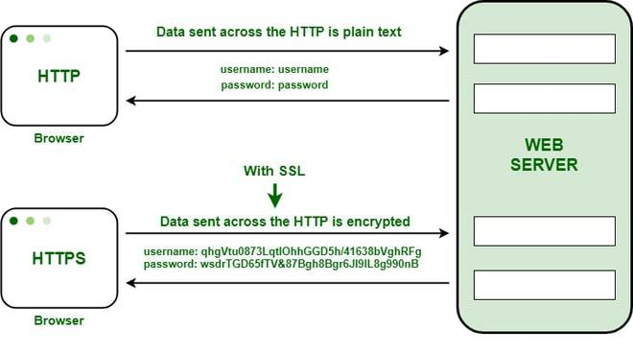

# LAB EXERCISE:

# Identify and explain three common application security vulnerabilities. Suggest possible solutions.

1. Structured Query Language (SQL)/Database Queries

This is the **most common area of application vulnerability** specifically due to the use of multiple databases in conjunction with multiple applications. SQL Injection attacks take place due to a flaw in the code of applications where the attacker successfully retrieves, alters, deletes data, executes SQL commands, or alters server configurations. In the reconnaissance stage, the hacker looks for spots in the application where they can inject undesired values to SQL commands.

For example, the attacker may use a string value for server queries to inject an escape sequence. The following is a potential SQL query for searching customers in a database:

SELECT * FROM customer WHERE name='” + strName + “‘; DROP TABLE customer;”

If the above SQL string input is not validated, it can execute a command to delete the customer table with the string name.

2. Broken Authentication

URL rewriting, application timeout not set properly, passwords not properly salted and hashed, or predictable login credentials are just a few causes of a broken authentication, in most cases of breaches at least. The prevalence of broken authentication in application (in)security is widespread. It is due to the weak implementation of identity and access controls. Certainly, session management forms the bedrock of the modern-day applications, but they are also not positioned well for many applications

### Some of the **application security best practices** for testing broken authentication are:

1. Check the existence of multi-factor authentication for credential stuffing, brute force, etc.
2. Admin users are allocated specific deployment credentials.
3. Check that credential recovery and API pathways are hardened.
4. Limit the number of failed login credentials.
5. Session IDs are not recorded or stored in public interfaces.

3. Cross-Site Scripting (CSS)

Cross-site scripting, CSS, or commonly abbreviated XSS, is the concept that gives attackers the ability to push malicious scripts into dynamic webpages. In many cases, these malicious programs inserted by hackers are disguised as legitimate data. Part of the problem is that the validity of scripts is not checked before execution – and can be programmed to steam passwords or reformat databases.

4. Modular Program and Container Security

Hopefully, all the core functions of applications – logic and programming, will stay within the bounds of the applications. However, with the wide adoption of containerization and orchestration technologies such as

Docker, Kubernetes, OpenShift and PCF, modular code is empowered at scale, propelling application programs and functions out of the testing boundaries

1. Secure the complete inventory of images, hosts, containers, registries, runtimes, and orchestration platforms.
2. Provide an IAM role per container or docker and follow the least privilege rule.
3. Scan for any vulnerabilities in the source of modular images.
4. Provision all container and modular code security tools in CI/CD pipelines.
5. Place container firewalls and policy engines explicitly.

5. Checking Networking and Communication Streams

For an application security tester, all outgoing and incoming network communications are to be treated as vulnerable. For instance, an application code may establish an FTP connection to retrieve an important file. The presence of tainted data can allow an attacker to modify listening server processes and intrude.

The above example is a small but potential vulnerability in applications. Modern enterprises work on ephemeral computing environments that are very dynamic in nature and are equally vulnerable to cyberthreats. Say an ecommerce company is preparing for the Black Friday and has opted for auto-scaling using Azure Autoscale. The trigger can result in the automatic installation of multiple resources such as VPCs, API Management service, Load Balancer, Azure Data Explorer Clusters, Logic Apps with auto provisioned Azure VMs, making it an overextended network infrastructure. Although such automation and auto-scaling of networking elements are the cornerstone of application agility, they require **new approaches of application security testing**.

How to test network security for applications?

1. Secure APIs by evaluating the sensitive data and resources they’re exposing – Amazon API Gateway implements Client-Side SSL Certificates for authentication by the backend.
2. Ensure appropriate in-app permissions – Azure Active Directory  provides authentication capabilities for applications.
3. Gate admin access based on real-time data – ensure that devices and users are not trusted only on internal networks.
4. Ensure all internal communications are encrypted for applications.
5. Employ microsegmentation for application network security.
6. Hardening and endpoint protection for applications are managed in tandem with changing network environments.

# THEORY EXERCISE:

# What is the role of encryption in securing applications?

Encryption is vital for securing applications by safeguarding sensitive data from unauthorized access and cyber threats. It converts readable data into an unreadable format, protecting information both at rest (stored) and in transit (being transmitted).

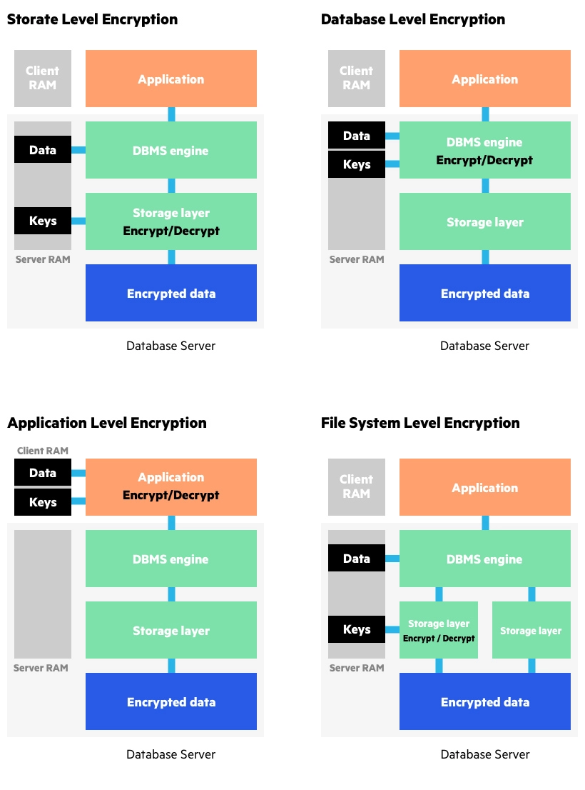

# 1. Protecting Data at Rest:

## Data in Databases and Storage:

Encryption secures sensitive data stored in databases, cloud environments, and on physical devices, preventing unauthorized access or theft, [according to Datcom Cloud](https://datcom.com.au/blog/encryption-role-in-data-protection).

## Backups:

Encrypting backups ensures that even if a backup is compromised, the data remains protected.

## 2. Protecting Data in Transit:

### Secure Communication:

Encryption protocols like [SSL/TLS](https://www.google.com/search?sca_esv=ad6d400188683837&q=SSL%2FTLS&sa=X&ved=2ahUKEwillIf13O6OAxXX6jgGHTEiCNEQxccNegUI7gEQAQ&mstk=AUtExfCLaCd_702ldqJwovIXELsCUrFEvx_7FyvQ_-7Caa47wN4Z8uNBavIBTl1-v9fCE1j0AG7kizq0SD3MejXTvMaRglOJIpVj6ejD78-NQZb3b0qTDFUR7gPHUXYslxP_Lzg&csui=3) and VPNs encrypt data transmitted over networks, like emails, instant messages, and file transfers, preventing interception and eavesdropping.

### Web Applications:

Encryption secures communication between web browsers and servers, ensuring the confidentiality of data exchanged during web browsing.

## 3. Benefits of Encryption in Application Security:

### Confidentiality:

Encryption ensures that only authorized parties can access and understand the data.

### Data Integrity:

Encryption can help verify that data has not been altered during transmission or storage.

### Compliance:

Many regulations, like GDPR and HIPAA, require encryption to protect sensitive personal information.

### Mitigation of Data Breaches:

In the event of a breach, encryption makes the stolen data unusable to attackers.

### Authentication:

Encryption can be part of authentication mechanisms to verify the identity of users and systems.

## 4. Types of Encryption:

[**Symmetric Encryption**](https://www.google.com/search?sca_esv=ad6d400188683837&q=Symmetric+Encryption&sa=X&ved=2ahUKEwillIf13O6OAxXX6jgGHTEiCNEQxccNegUI5QEQAQ&mstk=AUtExfCLaCd_702ldqJwovIXELsCUrFEvx_7FyvQ_-7Caa47wN4Z8uNBavIBTl1-v9fCE1j0AG7kizq0SD3MejXTvMaRglOJIpVj6ejD78-NQZb3b0qTDFUR7gPHUXYslxP_Lzg&csui=3): Uses the same key for encryption and decryption.

[**Asymmetric Encryption**](https://www.google.com/search?sca_esv=ad6d400188683837&q=Asymmetric+Encryption&sa=X&ved=2ahUKEwillIf13O6OAxXX6jgGHTEiCNEQxccNegUI7AEQAQ&mstk=AUtExfCLaCd_702ldqJwovIXELsCUrFEvx_7FyvQ_-7Caa47wN4Z8uNBavIBTl1-v9fCE1j0AG7kizq0SD3MejXTvMaRglOJIpVj6ejD78-NQZb3b0qTDFUR7gPHUXYslxP_Lzg&csui=3): Uses a pair of keys (public and private) for encryption and decryption.

# THEORY EXERCISE:

# Software Applications and Its Types.

Application software encompasses a wide range of programs designed to perform specific tasks for end-users. These can be broadly categorized into general-purpose applications, business applications, and specialized software like educational or multimedia tools

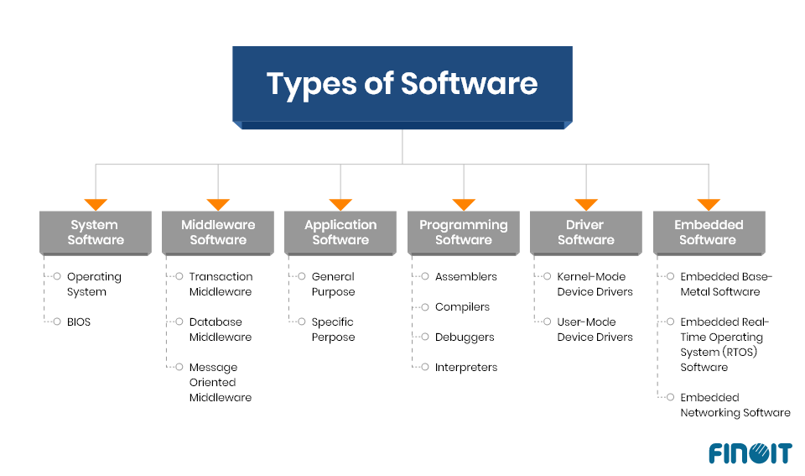

# LAB EXERCISE:

# Identify and classify 5 applications you use daily as either system software or application software.

# System Software:

## 1. Operating System (e.g., Windows, macOS, Android):

This is the foundational software that manages the computer's hardware and resources, providing a platform for other applications to run. Without it, no other software could function.

1. **2.**[**Device Drivers**](https://www.google.com/search?cs=1&sca_esv=871e6b959a619e82&q=Device+Drivers&sa=X&ved=2ahUKEwiPgvyS6e6OAxUCUGwGHej2BGwQxccNegQICBAB&mstk=AUtExfAQ6VbUg6P-DFbu3TzylWleiczAv2HBZw8-YgHfi007UDYIX0BdIp2Jks9jy9CPt18W5CLOe8s4pRGJ3x9rKBxZzTTcODnYiPc3sNppxatC0ZJUHK-0m0evURtE9Lltjrc&csui=3)**:**

These are specialized software programs that allow the operating system to communicate with and control hardware devices like printers, keyboards, and graphics cards. They are essential for the hardware to work correctly.

# Application Software:

1. Web Browser (e.g., Chrome, Firefox, Safari): Used for accessing and navigating the internet, including websites, web applications, and online content.
2. Email Client (e.g., Outlook, Gmail): Used for sending, receiving, and managing emails.
3. Word Processor (e.g., Microsoft Word, Google Docs): Used for creating, editing, and formatting text documents.

Explanation:

## System software

is the core software that manages the computer's resources and provides a platform for other software to run. It is essential for the computer to function.

## Application software

is designed for specific tasks or purposes, such as word processing, web browsing, or email communication. [According to TechTarget, application software](https://www.techtarget.com/searchapparchitecture/definition/software) is built to run on top of system software

# LAB EXERCISE:

# Design a basic three-tiersoftware architecture diagram for a web application.

A basic three-tier software architecture for a web application separates the application into three logical and often physical tiers: the Presentation Tier, the Logic Tier, and the Data Tier.

## 1. Presentation Tier (Client Tier):

### Purpose:

This tier is responsible for the user interface and user interaction. It presents information to the user and handles user input.

### Components:

Web browsers, HTML, CSS, JavaScript, front-end frameworks (e.g., React, Angular, Vue.js).

### Interaction:

Communicates with the Logic Tier to send user requests and receive data for display.

## 2. Logic Tier (Application Tier/Business Logic Tier):

### Purpose:

This tier contains the core business logic, processing, and application functionality. It acts as an intermediary between the Presentation Tier and the Data Tier.

### Components:

Web servers (e.g., Apache, Nginx), application servers (e.g., Node.js, Java Spring Boot, Python Django/Flask), APIs, business logic modules.

### Interaction:

Receives requests from the Presentation Tier, processes them according to business rules, and interacts with the Data Tier to store or retrieve data.

## 3. Data Tier (Database Tier):

* Purpose: This tier is responsible for data storage, management, and retrieval.

Components: Database servers (e.g., MySQL, PostgreSQL, MongoDB), data storage systems, data access layers (DALs).

**Interaction:** Stores and retrieves data as requested by the Logic Tier.

# THEORY EXERCISE:

# What is the significance of modularity in software architecture? Layers in Software Architecture

 software architecture, particularly in a [layered architecture](https://www.google.com/search?cs=1&sca_esv=871e6b959a619e82&q=layered+architecture&sa=X&ved=2ahUKEwiFzM-27O6OAxXg3TgGHdvdI60QxccNegQIBBAB&mstk=AUtExfB4_mu3gQxjoCTp0pqB_n_FG8BtC42o5SPKIl1ICbB0bgpqMbdl5NFmM0Tr4fDN_c-xU8FqWvempnHNplYAq_oOuMeSKlIsy5rnhvyMff-pXSZd6jNhLEolpi9sicQL5SA&csui=3), is significant because it enhances flexibility, reusability, maintainability, and efficiency. It allows for breaking down complex systems into smaller, manageable units (modules) with well-defined interfaces, enabling easier development, modification, and scaling.

Elaboration:

## What is Modularity?

Modularity, in the context of software, refers to the degree to which a system's components can be separated and recombined, like building blocks. A modular architecture decomposes a system into independent modules, each responsible for a specific set of functionalities, with well-defined interfaces for interaction with other modules.

Significance of Modularity:

### Flexibility:

Modularity allows for easy adaptation to changing requirements. Adding, modifying, or replacing modules can be done without affecting the entire system.

### Reusability:

Modular components can be reused in different parts of the same system or in other projects, saving development time and effort.

### Maintainability:

Isolating changes within modules simplifies maintenance, as updates or bug fixes can be applied without impacting the entire system.

### Efficiency in Development:

Modularity enables parallel development, where different teams or individuals can work on separate modules simultaneously, accelerating development cycles.

### Scalability:

By breaking down the system into independent modules, you can scale individual components based on their specific needs, rather than scaling the entire system.

### **Improved Understanding and Collaboration:**

Well-defined modules with clear responsibilities make the system easier to understand, facilitating collaboration among developers.

### Reduced Complexity:

Modularity helps to manage complexity by breaking down a large system into smaller, more manageable parts.

## Reduced Risk:

Modularity minimizes the risk of unintended consequences when making changes, as modifications are contained within specific modules.

Layers in Software Architecture:

Layered architecture is a specific type of modular architecture where the system is divided into horizontal layers, each responsible for a specific level of abstraction. For example, a typical layered architecture might include layers for presentation (UI), business logic, data access, and database. Each layer has a specific role and interacts with adjacent layers.

Benefits of Layered Architecture:

### Separation of Concerns:

Each layer has a specific responsibility, making the code more organized, easier to understand, and easier to maintain.

### Independent Evolution:

Layers can evolve independently, allowing for changes in one layer without affecting other layers.

### Improved Testability:

Isolating functionality within layers makes it easier to test individual components.

### Enhanced Security:

Layers can be used to implement security measures at different levels of abstraction, enhancing the overall security of the system.

## Example:

Consider a shopping cart application. In a layered architecture, you might have a presentation layer (displaying the cart and items), a business logic layer (calculating total, applying discounts), a data access layer (reading/writing data from the database), and a database layer (storing cart information). Each layer is independent, and changes can be made to one layer without affecting the others, as long as the interfaces between layers are maintained.

In conclusion, modularity, especially in a layered architecture, is crucial for building complex, scalable, and maintainable software systems. It promotes flexibility, reusability, and efficiency, making it an essential concept in modern software development.

# LAB EXERCISE:

# Create a case study on the functionality of the presentation, business logic, and data access layers of a given software system.

A case study on the functionality of the presentation, business logic, and data access layers of a given software system can be developed by considering a common application, such as an online e-commerce platform.

## 1. Presentation Layer (UI Layer):

### Functionality:

This layer is responsible for user interaction, displaying information, and collecting user input. In an e-commerce platform, this includes the website's front-end elements like product display pages, shopping cart interfaces, user account management forms, and checkout pages. It handles user events (clicks, form submissions) and translates them into requests for the business logic layer.

### Example:

When a user navigates to a product page, the presentation layer renders the product details (image, description, price) retrieved from the business logic layer. When a user adds an item to the cart, the presentation layer captures this action and sends a request to the business logic layer to update the cart.

### 2. Business Logic Layer (BLL):

* **Functionality:**

This layer contains the core business rules and operations of the application. It acts as an intermediary between the presentation and data access layers, enforcing business rules, performing calculations, and coordinating data flow. It ensures data consistency and integrity.

### Example:

## In an e-commerce platform, the BLL would handle:

* + Product Management: Validating product details, managing inventory, applying discounts.
  + Order Processing: Calculating order totals, applying shipping rules, generating order confirmations.
  + User Management: Authenticating users, managing user profiles, handling password resets.
  + Cart Management: Adding/removing items, calculating cart totals, applying promotions.

It receives requests from the presentation layer, applies business rules, and then interacts with the data access layer to retrieve or store necessary data.

### 3. Data Access Layer (DAL):

## Functionality:

This layer is responsible for interacting with the underlying data storage mechanism, such as a database. It abstracts the complexities of data retrieval and persistence from the business logic layer, providing methods for performing CRUD (Create, Read, Update, Delete) operations on data.

### Example:

For an e-commerce platform, the DAL would contain methods to:

* + Retrieve Products: Fetch product information from the database based on criteria like ID, category, or search terms.
  + Save Orders: Persist new order details, including line items and customer information, into the database.
  + Update Inventory: Modify product quantities in the database after a purchase.
  + Authenticate Users: Query the database to verify user credentials.

It receives requests from the BLL, translates them into database queries (e.g., SQL), executes them, and returns the results to the BLL.

Interaction Flow Example (Adding a Product to Cart):

### Presentation Layer:

User clicks "Add to Cart" button on a product page. The presentation layer captures this event and sends a request (e.g., addToCart(productId, quantity)) to the BLL.

### Business Logic Layer:

The BLL receives the addToCart request. It validates the productId and quantity (e.g., ensuring quantity is positive and productId exists). It then calls a method in the DAL (e.g., getProductById(productId)) to retrieve product details and potentially updateInventory(productId, -quantity). Finally, it updates the user's shopping cart state and sends a confirmation or error message back to the presentation layer.

### Data Access Layer:

The DAL receives the getProductById and updateInventory requests. It connects to the database, executes the necessary SQL queries (e.g., SELECT * FROM Products WHERE Id = productId, UPDATE Products SET Quantity = Quantity - quantity WHERE Id = productId), and returns the results or status to the BLL.

### Presentation Layer:

Receives the confirmation or error message from the BLL and updates the UI accordingly (e.g., displaying a "Product added to cart" message or an error notification).

# THEORY EXERCISE:

# Why are layers important in software architecture? Software Environments

Layers are crucial in software architecture because they promote modularity, improve maintainability, and enhance the overall structure of a system. Benefits of Layers:

## Modularity and Separation of Concerns:

Layers enable developers to focus on specific functionalities within a layer without needing to understand the complexities of other layers. This promotes modularity, allowing for independent development and easier maintenance of individual components.

### Improved Maintainability:

Layered architectures make it easier to understand, modify, and extend the system over time. Changes in one layer are less likely to affect other layers, minimizing the risk of introducing bugs and simplifying debugging.

### Enhanced Testability:

Each layer can be tested independently, making it easier to isolate and fix issues. This leads to more efficient and thorough testing processes.

### Scalability:

Layered architectures can be scaled more easily by adding new layers or modifying existing ones to accommodate new functionalities or increased load.

### Code Reuse:

Layered architectures promote code reuse as specific layers or components can be extracted and used in other projects or modules.

### Reduced Complexity:

Breaking down a complex system into smaller, more manageable layers reduces the overall complexity of the software.

### A typical layered architecture in a web application might include:

1. Presentation Layer: Handles user interface and interactions (e.g., HTML, CSS, JavaScript).
2. Business Logic Layer: Contains the core business rules and logic.
3. Data Access Layer: Manages interactions with the database.

Layers are a fundamental concept in software architecture, providing numerous benefits that contribute to the development of robust, maintainable, and scalable software systems.

# LAB EXERCISE:

# Explore different types of software environments (development, testing, production). Set up a basic environment in a virtual machine.

## 1. Exploring Software Environments:

### Development Environment:

**Testing Environment:** This is where developers write, debug, and initially test code. It typically includes an Integrated Development Environment (IDE), version control tools, and local databases or servers. The focus is on rapid iteration and individual developer productivity.

### Testing:

This environment is dedicated to comprehensive quality assurance (QA). Various types of testing, such as functional, performance, security, and integration testing, are conducted here. It aims to closely mirror the production environment to identify defects and ensure stability before deployment.

### Production Environment:

This is the live environment where the software is deployed and accessible to end-users. It is designed for stability, performance, and security, with minimal changes or debugging occurring directly within it.

## 2. Setting Up a Basic Environment in a Virtual Machine:

This procedure outlines setting up a basic development environment using a Linux-based virtual machine (VM).

### Install Virtualization Software:

Install a virtualization platform like Oracle VirtualBox or VMware Workstation/Fusion on your host machine.

### Download a Linux Distribution:

Obtain an ISO image of a lightweight Linux distribution, such as Ubuntu Server or Debian.

## Create a New Virtual Machine:

Launch your virtualization software and create a new VM.

Allocate sufficient RAM and CPU cores (e.g., 2GB RAM, 2 CPUs).

Create a virtual hard disk (e.g., 20GB).

Mount the downloaded Linux ISO as the virtual CD/DVD drive.

### Install the Operating System:

Start the VM and follow the on-screen prompts to install the chosen Linux distribution.

Configure user accounts, network settings, and package selections as needed.

### Install Development Tools:

Once the OS is installed and you can log in, open a terminal.

Update package lists:

### Code

sudo apt update

Install a text editor (e.g., Vim, Nano) or a lightweight IDE (e.g., VS Code Server):

### Code

sudo apt install vim  
 *# or for VS Code Server setup:*  
 # Refer to VS Code Server documentation for installation instructions

Install a programming language runtime (e.g., Python, Node.js, Java Development Kit):

### Code

sudo apt install python3

Install Git for version control.

### Code

sudo apt install git

**Verify the Setup:**

Confirm the installed tools by checkiTHEORYng their versions:

### Code

python3 --version  
 git –version

# THEORY EXERCISE:

# Explain the importance of a development environment in software production. Source Code

A development environment is crucial in software production as it provides a dedicated space for developers to write, test, and debug code without affecting live users or the production environment. It allows for experimentation, error correction, and iterative development, ultimately leading to more stable, reliable, and efficient software.

## 1. Isolation and Safety:

A development environment isolates code changes from the live production environment, preventing accidental disruptions or errors from impacting users.

It allows developers to freely experiment with new features, algorithms, and code modifications without the risk of causing immediate problems for the end-users.

## 2. Enhanced Testing and Debugging:

Development environments provide a platform for thorough testing, including unit testing, integration testing, and system testing.

Developers can identify and fix bugs early in the development cycle, minimizing the chances of them reaching the production environment.

* [According to Unitrends, a test environment is essential for ensuring that code works as intended before release](https://www.unitrends.com/blog/development-test-environments/).

## 3. Streamlined Development Process:

Development environments often include tools and features that streamline the development workflow, such as integrated development environments (IDEs), version control systems, and automated build processes.

These tools enhance developer productivity and collaboration, making the overall development process more efficient.

## 4. Iterative Development:

Development environments enable iterative development, where changes are made in small increments and tested thoroughly at each stage.

This approach allows for continuous improvement and adaptation to changing requirements, leading to a more robust and user-friendly final product.

## 5. Reduced Risk and Cost:

By catching errors early in the development process, development environments help reduce the risk of costly fixes and delays later on.

A well-managed development environment contributes to a more stable and reliable software product, minimizing the need for emergency bug fixes and updates in the production environment.

# LAB EXERCISE:

# Write and upload your first source code file to Github.

## Create a GitHub Account and Repository:

If you do not have a GitHub account, create one on the GitHub website.

Create a new repository on GitHub. Give it a descriptive name (e.g., "my-first-code") and optionally add a README file.

## Write Your Source Code:

Open a text editor or an Integrated Development Environment (IDE) on your local machine.

Write your source code in a language of your choice (e.g., Python, Java, C++).

Save the file with an appropriate extension (e.g., my_script.py, HelloWorld.java, main.cpp).

## Upload the File to GitHub (Web Interface Method):

Navigate to your newly created repository on the GitHub website.

Click on the "Add file" dropdown menu and select "Upload files".

Drag and drop your source code file(s) into the designated area, or click "choose your files" to select them from your computer.

Add a concise commit message in the "Commit changes" section (e.g., "Initial commit: Added my first Python script").

Ensure "Commit directly to the main branch" is selected (or choose to create a new branch if preferred).

Click "Commit changes".

## Upload the File to GitHub (Git Command Line Method - Alternative):

* + Install Git: Ensure Git is installed on your local machine.
  + Clone the Repository: Open your terminal or command prompt and navigate to the directory where you want to store your local repository. Execute the command:

### Code

git clone <your_repository_url>

Replace <your_repository_url> with the URL of your GitHub repository.

### Add Your File:

Copy your source code file into the newly cloned local repository directory.

### Stage the File:

In your terminal, navigate into the cloned repository directory and execute:

### Code

git add <your_file_name>

Or, to add all changes in the current directory:

### Code

git add .

Commit the Changes.

### Code

git commit -m "Initial commit: Added my first source code file"

Push to GitHub.

### Code

git push origin main

# THEORY EXERCISE:

# What is the difference between source code and machine code? Github and Introductions

The main difference between source code and machine code is that the source code is the programming of non-executable but standardized language code that is converted. In contrast, the machine code is the actual executable code

GitHub is a web-based platform that uses Git, a version control system, to facilitate collaboration and code management for software development

### Git and GitHub:

Git is a powerful tool for tracking changes in files, while GitHub is a platform that hosts Git repositories.

### Collaboration:

GitHub enables multiple developers to work on the same project simultaneously by providing features like branching, merging, and pull requests.

### Version Control:

Git tracks all changes made to the project, allowing developers to revert to previous versions if needed.

### Centralized Hub:

GitHub acts as a central location for storing and managing projects, making it easier for teams to collaborate and track progress.

### Real-time Updates:

Changes made by one collaborator are visible to others in real-time, promoting transparency and efficient communication.

### Branching:

Developers can create separate branches for new features or bug fixes, isolating changes and making it easier to manage different versions of the code.

### Pull Requests:

Once a developer finishes working on a feature, they can create a pull request to merge their changes into the main branch, allowing for code review and feedback before integration.

LAB EXERCISE:

* Create a Github repository and document how to commit and push code changes.

This lab exercise outlines the process of creating a GitHub repository and subsequently committing and pushing code changes to it.

## 1. Create a GitHub Repository:

Navigate to GitHub and log in to your account.

Click the "+" icon in the upper-right corner and select "New repository."

Provide a repository name (e.g., my-project).

Optionally, add a description and choose visibility (public or private).

Select "Initialize this repository with a README" (recommended for new projects).

Click "Create repository."

## 2. Initialize a Local Git Repository and Connect to GitHub:

* Open your terminal or command prompt.
* Navigate to your project directory (e.g., cd my-project).
* Initialize a local Git repository:

Code

git init

Add the remote origin, linking your local repository to the GitHub repository. Replace USERNAME and REPOSITORY_NAME with your actual GitHub username and repository name:

Code

git remote add origin https://github.com/USERNAME/REPOSITORY_NAME.git

## 3. Commit and Push Code Changes:

Make changes to your project files and Stage the changes for commit.

### Code

git add .

(This command stages all modified and new files. You can also specify individual files, e.g., git add index.html).

Commit the staged changes with a descriptive message:

### Code

git commit -m "Initial commit of project files"

(Replace the message with a brief summary of your changes).

Push the committed changes to the GitHub repository:

### Code

git push -u origin main

(Replace main with master if your default branch is named master). The -u flag sets the upstream branch, so subsequent git push commands can be run without specifying origin main.

## 4. Verify Changes:

Refresh your GitHub repository page in your web browser. You should see your committed files and the commit history.

# THEORY EXERCISE

# Why is version control important in software development? Student Account in Github

## Tracking and Managing Changes:

Version control systems (VCS) record every modification made to the codebase, including who made the change, when it was made, and why. This creates a detailed history, allowing developers to understand the evolution of the project and easily revert to previous versions if errors or issues arise.

## Facilitating Collaboration:

In team environments, multiple developers often work on the same codebase simultaneously. Version control enables seamless collaboration by providing mechanisms to merge changes, resolve conflicts when different developers modify the same files, and ensure everyone is working on the most up-to-date version of the code.

## Ensuring Code Integrity and Safety:

VCS acts as a safety net, protecting the source code from accidental deletions, unintended consequences of changes, and catastrophic failures. It provides a reliable backup and allows for experimentation without fear of permanently damaging the project.

## Supporting Non-linear Development:

Modern VCS allows for branching and merging, enabling developers to work on new features or bug fixes in isolation without affecting the main codebase. This supports parallel development, making it easier to manage multiple ongoing tasks and integrate them smoothly when ready.

## Improving Accountability and Debugging:

The comprehensive history maintained by VCS provides an audit trail, making it easy to identify who introduced specific changes, which is invaluable for debugging issues and understanding the impact of different modifications.

### Student account in github?

DataCamp has partnered with **GitHub** Education to offer three months of free access when you sign up for a DataCamp subscription with your **GitHub student account**

# LAB EXERCISE:

# Create a student account on Github and collaborate on a small project with a classmate.

create a student account in GitHub.

### You qualify for GitHub Education if you:

Are enrolled in a degree- or diploma-granting program, such as a high school, college, university, or homeschool.

Have a verifiable school-issued email or documents proving your student status.

Own a GitHub personal account.

Are at least 13 years old.

How to collab on a project in GitHub.

**For collaborations:**

Make a repository on GitHub.

Give your collaborators access to that GitHub repository.

Each of you write out issues for the project work.

Assign yourself an issue.

Clone the repo to your local computer.

Create a branch, then work as normal add ing and commit ing files as you work.

## 1. Create a GitHub Account:

Navigate to the GitHub website and sign up for a new account. Provide the required information, including a username, email address, and password.

Verify your email address to activate your account.

2. Apply for GitHub Education Student Benefits:

Visit the GitHub Education website and apply for the GitHub Global Campus Student benefits.

During the application process, select "Student" as your role and provide proof of your academic status, such as a student ID or an official school email address.

Once approved, you will gain access to various student-specific resources and benefits, including the GitHub Student Developer Pack.

## 3. Set up a Project Repository:

### Create a new repository:

On your GitHub profile, click the "New" button to create a new repository for your project.

### Name the repository:

Choose a descriptive name for your project.

### Initialize with a README (optional):

Consider checking the box to initialize the repository with a README file, which provides a basic description of your project.

### Choose visibility:

Decide whether the repository should be public or private. For collaborative projects, private repositories are often preferred.

## 4. Invite Your Classmate as a Collaborator:

Navigate to the settings of your project repository.

In the "Access" section of the sidebar, click on "Collaborators."

Click "Add people" and search for your classmate's GitHub username.

Select their username and click "Add NAME to REPOSITORY" to send an invitation.

Your classmate will receive an email invitation to collaborate on the repository, which they must accept.

## 5. Collaborate on the Project:

### Clone the repository:

Both you and your classmate should clone the repository to your local machines using Git.

### Make changes:

Work on different aspects of the project, making changes to the code or files within the cloned repository.

### Commit changes:

Regularly commit your changes with descriptive commit messages.

### Push and Pull:

Use git push to upload your local changes to the remote repository on GitHub and git pull to download your classmate's changes and keep your local copy updated.

### Create branches (optional):

For more complex features or bug fixes, consider creating separate branches to work on before merging them into the main branch.

### Use Pull Requests:

When a feature or fix is ready, create a Pull Request to propose merging your changes into the main branch. This allows for code review and discussion before merging.

# THEORY EXERCISE:

# What are the benefits of using Github for students? Types of Software

GitHub is a cloud-based platform with over 40 million users. It is widely used in the open-source community and is also becoming an important tool for SE educators. GitHub can provide students with real-world software development experiences and encourage communication, collaboration.

 system software and application software. System software manages the computer's hardware and provides a platform for other software to run, while application software is designed to perform specific tasks for users.

Here's a more detailed breakdown:

1. [System Software](https://www.google.com/search?sca_esv=1263d0ef7397b8b5&q=System+Software&sa=X&ved=2ahUKEwj5-feVj--OAxWRxzgGHbYcO7QQxccNegQIJhAC&mstk=AUtExfAuY9NgpgtjzmcB4VnK7qf2K7Cy819Ho2vur78K5h89x6JtBen2fQmlkIvHSJ9z4AsZqX5Q5sqOvk1sqfXs3zhLNrfi0w0p1FcRQGdgMpr7xgL11eTOstOind-PEYAdhTo&csui=3):

[**Operating System (OS)**](https://www.google.com/search?sca_esv=1263d0ef7397b8b5&q=Operating+System+%28OS%29&sa=X&ved=2ahUKEwj5-feVj--OAxWRxzgGHbYcO7QQxccNegQIMhAB&mstk=AUtExfAuY9NgpgtjzmcB4VnK7qf2K7Cy819Ho2vur78K5h89x6JtBen2fQmlkIvHSJ9z4AsZqX5Q5sqOvk1sqfXs3zhLNrfi0w0p1FcRQGdgMpr7xgL11eTOstOind-PEYAdhTo&csui=3)**:**

The core software that manages computer hardware and software resources, like Windows, macOS, or Linux.

[**Language Processors**](https://www.google.com/search?sca_esv=1263d0ef7397b8b5&q=Language+Processors&sa=X&ved=2ahUKEwj5-feVj--OAxWRxzgGHbYcO7QQxccNegUIgAEQAQ&mstk=AUtExfAuY9NgpgtjzmcB4VnK7qf2K7Cy819Ho2vur78K5h89x6JtBen2fQmlkIvHSJ9z4AsZqX5Q5sqOvk1sqfXs3zhLNrfi0w0p1FcRQGdgMpr7xgL11eTOstOind-PEYAdhTo&csui=3)**:**

Programs that translate code written in programming languages into machine-executable code (e.g., compilers, interpreters).

[**Device Drivers**](https://www.google.com/search?sca_esv=1263d0ef7397b8b5&q=Device+Drivers&sa=X&ved=2ahUKEwj5-feVj--OAxWRxzgGHbYcO7QQxccNegQIfhAB&mstk=AUtExfAuY9NgpgtjzmcB4VnK7qf2K7Cy819Ho2vur78K5h89x6JtBen2fQmlkIvHSJ9z4AsZqX5Q5sqOvk1sqfXs3zhLNrfi0w0p1FcRQGdgMpr7xgL11eTOstOind-PEYAdhTo&csui=3)**:**

Software that allows the OS to communicate with hardware devices like printers, mice, and network cards.

2. [Application Software](https://www.google.com/search?sca_esv=1263d0ef7397b8b5&q=Application+Software&sa=X&ved=2ahUKEwj5-feVj--OAxWRxzgGHbYcO7QQxccNegQIexAC&mstk=AUtExfAuY9NgpgtjzmcB4VnK7qf2K7Cy819Ho2vur78K5h89x6JtBen2fQmlkIvHSJ9z4AsZqX5Q5sqOvk1sqfXs3zhLNrfi0w0p1FcRQGdgMpr7xgL11eTOstOind-PEYAdhTo&csui=3):

* **General-Purpose Software:**

Software designed for a wide range of users and tasks (e.g., word processors, web browsers, spreadsheets, media players).

[**Custom Software**](https://www.google.com/search?sca_esv=1263d0ef7397b8b5&q=Custom+Software&sa=X&ved=2ahUKEwj5-feVj--OAxWRxzgGHbYcO7QQxccNegUIlQEQAQ&mstk=AUtExfAuY9NgpgtjzmcB4VnK7qf2K7Cy819Ho2vur78K5h89x6JtBen2fQmlkIvHSJ9z4AsZqX5Q5sqOvk1sqfXs3zhLNrfi0w0p1FcRQGdgMpr7xgL11eTOstOind-PEYAdhTo&csui=3)**:**

Software developed for specific needs of an individual or organization (e.g., accounting software, inventory management).

## [Utility Software](https://www.google.com/search?sca_esv=1263d0ef7397b8b5&q=Utility+Software&sa=X&ved=2ahUKEwj5-feVj--OAxWRxzgGHbYcO7QQxccNegUIkwEQAQ&mstk=AUtExfAuY9NgpgtjzmcB4VnK7qf2K7Cy819Ho2vur78K5h89x6JtBen2fQmlkIvHSJ9z4AsZqX5Q5sqOvk1sqfXs3zhLNrfi0w0p1FcRQGdgMpr7xgL11eTOstOind-PEYAdhTo&csui=3):

Software that performs maintenance and management tasks on the computer (e.g., disk defragmenters, antivirus software).

Other important types of software include:

## [Programming Software](https://www.google.com/search?sca_esv=1263d0ef7397b8b5&q=Programming+Software&sa=X&ved=2ahUKEwj5-feVj--OAxWRxzgGHbYcO7QQxccNegUIkgEQAQ&mstk=AUtExfAuY9NgpgtjzmcB4VnK7qf2K7Cy819Ho2vur78K5h89x6JtBen2fQmlkIvHSJ9z4AsZqX5Q5sqOvk1sqfXs3zhLNrfi0w0p1FcRQGdgMpr7xgL11eTOstOind-PEYAdhTo&csui=3):

Tools used by programmers to develop other software (e.g., IDEs, debuggers).

## [Embedded Software](https://www.google.com/search?sca_esv=1263d0ef7397b8b5&q=Embedded+Software&sa=X&ved=2ahUKEwj5-feVj--OAxWRxzgGHbYcO7QQxccNegUIkQEQAQ&mstk=AUtExfAuY9NgpgtjzmcB4VnK7qf2K7Cy819Ho2vur78K5h89x6JtBen2fQmlkIvHSJ9z4AsZqX5Q5sqOvk1sqfXs3zhLNrfi0w0p1FcRQGdgMpr7xgL11eTOstOind-PEYAdhTo&csui=3):

Software that runs on specialized hardware, often found in devices like appliances, cars, and industrial equipment.

## [**Middleware**](https://www.google.com/search?sca_esv=1263d0ef7397b8b5&q=Middleware&sa=X&ved=2ahUKEwj5-feVj--OAxWRxzgGHbYcO7QQxccNegUIkAEQAQ&mstk=AUtExfAuY9NgpgtjzmcB4VnK7qf2K7Cy819Ho2vur78K5h89x6JtBen2fQmlkIvHSJ9z4AsZqX5Q5sqOvk1sqfXs3zhLNrfi0w0p1FcRQGdgMpr7xgL11eTOstOind-PEYAdhTo&csui=3)**:**

Software that acts as a bridge between system software and application software.

## [**Web Applications**](https://www.google.com/search?sca_esv=1263d0ef7397b8b5&q=Web+Applications&sa=X&ved=2ahUKEwj5-feVj--OAxWRxzgGHbYcO7QQxccNegUIjgEQAQ&mstk=AUtExfAuY9NgpgtjzmcB4VnK7qf2K7Cy819Ho2vur78K5h89x6JtBen2fQmlkIvHSJ9z4AsZqX5Q5sqOvk1sqfXs3zhLNrfi0w0p1FcRQGdgMpr7xgL11eTOstOind-PEYAdhTo&csui=3)**:**

Software accessed through a web browser, like online shopping sites or social media platforms.

## [**Artificial Intelligence (AI) Software**](https://www.google.com/search?sca_esv=1263d0ef7397b8b5&q=Artificial+Intelligence+%28AI%29+Software&sa=X&ved=2ahUKEwj5-feVj--OAxWRxzgGHbYcO7QQxccNegUIjwEQAQ&mstk=AUtExfAuY9NgpgtjzmcB4VnK7qf2K7Cy819Ho2vur78K5h89x6JtBen2fQmlkIvHSJ9z4AsZqX5Q5sqOvk1sqfXs3zhLNrfi0w0p1FcRQGdgMpr7xgL11eTOstOind-PEYAdhTo&csui=3)**:**

Software that exhibits intelligent behavior, including machine learning, natural language processing, and computer vision.

# LAB EXERCISE:

# Create a list of software you use regularly and classify them into the following categories: system, application, and utility software.

# System Software:

# Operating System (OS):

Windows, macOS, or Linux. These manage the computer's resources and provide a platform for other software to run.

# Device Drivers:

Software that allows the operating system to communicate with hardware components like printers, graphics cards, etc.

Application Software:

# Web Browsers:

 Chrome, Firefox, Safari, etc., used for accessing the internet.

Productivity Suites: Microsoft Office (Word, Excel, PowerPoint), Google Workspace (Docs, Sheets, Slides), which includes various tools for document creation, data analysis, and presentations.

Email Clients: Outlook, Gmail, Thunderbird for managing email.

Multimedia Players: VLC, iTunes, for playing audio and video files.

Communication Software: Slack, Zoom, Skype for communication and collaboration.

Image Editing Software: Photoshop, GIMP, for editing and manipulating images.

# Utility Software:

Antivirus Software: Norton, McAfee, for protecting against malware.

Disk Cleanup Tools: CCleaner, for removing unnecessary files and optimizing disk space.

File Compression Tools: 7-Zip, WinRAR, for compressing and decompressing files.

System Optimizers: For enhancing performance and stability.

Backup and Recovery Tools: Acronis, Macrium Reflect, for creating backups of data and systems.

# THEORY EXERCISE:

# What are the differences between open-source and proprietary software? GIT and GITHUB Training

Open-source and proprietary software differ primarily in terms of access to source code, licensing, development model, and cost.

## Open-Source Software:

### Source Code Access:

The source code is freely available for users to view, modify, and distribute.

### Licensing:

Typically released under open-source licenses (e.g., MIT, GPL) that grant users specific freedoms, including the right to use, study, modify, and distribute the software.

## Development Model:

Often developed collaboratively by a community of developers, fostering transparency and collective improvement.

### Cost:

Frequently free to use, though support or specialized features may come at a cost.

### Flexibility:

Highly customizable as users can modify the source code to suit specific needs.

## Proprietary Software:

### Source Code Access:

The source code is private and owned by the developer or vendor; users cannot access or modify it.

### Licensing:

Users purchase licenses or subscriptions to use the software, with restrictions on use, distribution, and modification.

## Development Model:

Developed and maintained by a closed team within the owning company or organization.

### Cost:

Typically requires payment for licenses, subscriptions, or support.

### Flexibility:

Limited customization options, as users cannot alter the core functionality or source code.

### GIT and GITHUB Training:

While n-source and proprietary software represent distinct models, tools like Git and platforms like GitHub are widely used in both environments for version control and collaboration.

### Git:

An open-source, distributed version control system that tracks changes in source code during software development. It allows developers to manage different versions of their code, collaborate effectively, and revert to previous states if needed.

### GitHub:

A web-based platform that provides hosting for Git repositories. While it offers free tiers, it also provides paid features and services. GitHub facilitates collaboration on Git projects through features like pull requests, issue tracking, and project management tools, making it a central hub for both open-source and proprietary software development teams.

# LAB EXERCISE:

# Follow a GIT tutorial to practice cloning, branching, and merging repositories.

## Git cloning, branching, and merging, follow these steps:

## 1. Clone a Repository:

Identify a remote repository: Choose a repository you want to clone, either a public one (e.g., from GitHub, GitLab) or one you've created.

**Copy the repository URL:** Locate the "Clone" or "Code" button on the repository's hosting platform and copy the HTTPS or SSH URL.

Open your terminal or Git Bash: Navigate to the directory where you want to store the cloned repository.

### Execute the clone command:

### Code

git clone <repository-url>

Replace <repository-url> with the URL you copied. This will create a local copy of the repository, including all files and commit history.

## 2. Create and Work on a Branch:

Navigate into the cloned repository.

### Code

cd <repository-name>

Replace <repository-name> with the name of the cloned repository. Create a new branch.

### Code

git branch <new-branch-name>

Choose a descriptive name for your new branch. Switch to the new branch.

### Code

git checkout <new-branch-name>

Make changes and commit them: Modify files, add new ones, or delete existing ones. Then stage and commit your changes:

Code

git add .  
 git commit -m "Description of your changes on the new branch"

## 3. Merge Branches:

Switch back to the main branch (e.g., main or master):

### Code

git checkout main

**Merge your feature branch into the main branch:**

### Code

git merge <new-branch-name>

Git will attempt to integrate the changes from your feature branch into the main branch. If there are conflicts, Git will notify you, and you will need to resolve them manually before completing the merge.

## 4. Verify the Merge:

Check the commit history.

### Code

git log --oneline --graph

# THEORY EXERCISE:

# How does GIT improve collaboration in a software development team? Application Software

Git significantly improves collaboration in a software development team through its core features and distributed nature:

## Distributed Version Control:

Each developer possesses a complete local copy of the repository, including its full history. This decentralization enables independent work without constant network connectivity and reduces reliance on a central server, minimizing single points of failure.

## Branching and Merging:

Git's robust branching model allows developers to create isolated branches for new features, bug fixes, or experimental work. This enables parallel development, preventing interference with the main codebase. Once work on a branch is complete, it can be seamlessly merged back into the main branch, integrating changes efficiently.

## Conflict Resolution:

When multiple developers modify the same lines of code, Git provides mechanisms to detect and help resolve merge conflicts. This ensures that conflicting changes are addressed and integrated correctly, preventing data loss and maintaining code integrity.

## Code Review and Pull Requests:

Platforms built on Git, such as GitHub, GitLab, and Bitbucket, facilitate code review through pull requests (or merge requests). Developers can submit their changes for peer review, fostering knowledge sharing, improving code quality, and catching potential issues early in the development cycle.

## Detailed History and Revert Capabilities:

Git meticulously tracks every change made to the codebase, including who made it, when, and why. This comprehensive history allows for easy identification of changes, debugging, and the ability to revert to any previous state of the code if necessary, providing a safety net for collaborative development.

## Enhanced Communication and Transparency:

The process of creating branches, committing changes with descriptive messages, and submitting pull requests naturally encourages clear communication within the team about ongoing work and proposed changes. This transparency improves coordination and reduces misunderstandings.

# LAB EXERCISE:

* Write a report on the various types of application software and how they improve productivity.

Application software enhances productivity by streamlining tasks, improving communication, and facilitating data management. Key types include word processors, spreadsheets, presentation software, and communication tools, each offering unique benefits for efficiency and collaboration.

# Types of Application Software and Their Impact on Productivity:

# 1. [**Word Processors**](https://www.google.com/search?cs=1&sca_esv=9576322275790996&q=Word+Processors&sa=X&ved=2ahUKEwjLqZ-DhfCOAxXpTWwGHZpYNOkQxccNegQIIBAB&mstk=AUtExfCYV2tyZ73TbFDWW3XDI6l_Et9fThvOIlmEgpsBR1TFcay4gxR0505Yj4O9H8X-PdUVY4DOHDAAZqVgP40wJKcXC8r1_sxAVWCVZeg7-oaejYBoGrx5iD4YACWCyM_m0bc&csui=3):

These tools, like Microsoft Word and Google Docs, enable users to create, edit, and format text documents efficiently. They offer features like spell check, grammar check, and formatting options, which significantly improve the quality and speed of document creation.

# 2. [**Spreadsheet Software**](https://www.google.com/search?cs=1&sca_esv=9576322275790996&q=Spreadsheet+Software&sa=X&ved=2ahUKEwjLqZ-DhfCOAxXpTWwGHZpYNOkQxccNegQIJBAB&mstk=AUtExfCYV2tyZ73TbFDWW3XDI6l_Et9fThvOIlmEgpsBR1TFcay4gxR0505Yj4O9H8X-PdUVY4DOHDAAZqVgP40wJKcXC8r1_sxAVWCVZeg7-oaejYBoGrx5iD4YACWCyM_m0bc&csui=3):

Programs such as Microsoft Excel and Google Sheets allow users to organize, analyze, and manipulate data in a structured format. They facilitate calculations, charting, and data visualization, which are essential for tasks like financial analysis, project management, and data reporting.

# 3. [**Presentation Software**](https://www.google.com/search?cs=1&sca_esv=9576322275790996&q=Presentation+Software&sa=X&ved=2ahUKEwjLqZ-DhfCOAxXpTWwGHZpYNOkQxccNegQIJhAB&mstk=AUtExfCYV2tyZ73TbFDWW3XDI6l_Et9fThvOIlmEgpsBR1TFcay4gxR0505Yj4O9H8X-PdUVY4DOHDAAZqVgP40wJKcXC8r1_sxAVWCVZeg7-oaejYBoGrx5iD4YACWCyM_m0bc&csui=3):

Software like Microsoft PowerPoint and Google Slides enables users to create engaging visual presentations. These tools offer features for designing slides, incorporating multimedia, and delivering information in a clear and concise manner, enhancing communication and information sharing.

# 4. [**Communication Software**](https://www.google.com/search?cs=1&sca_esv=9576322275790996&q=Communication+Software&sa=X&ved=2ahUKEwjLqZ-DhfCOAxXpTWwGHZpYNOkQxccNegQIIhAB&mstk=AUtExfCYV2tyZ73TbFDWW3XDI6l_Et9fThvOIlmEgpsBR1TFcay4gxR0505Yj4O9H8X-PdUVY4DOHDAAZqVgP40wJKcXC8r1_sxAVWCVZeg7-oaejYBoGrx5iD4YACWCyM_m0bc&csui=3):

Applications like Slack, Skype, and Microsoft Teams facilitate real-time communication and collaboration among individuals or teams. They offer features like instant messaging, video conferencing, and file sharing, which streamline communication and improve teamwork.

# 5. [**Web Browsers**](https://www.google.com/search?cs=1&sca_esv=9576322275790996&q=Web+Browsers&sa=X&ved=2ahUKEwjLqZ-DhfCOAxXpTWwGHZpYNOkQxccNegQIJRAB&mstk=AUtExfCYV2tyZ73TbFDWW3XDI6l_Et9fThvOIlmEgpsBR1TFcay4gxR0505Yj4O9H8X-PdUVY4DOHDAAZqVgP40wJKcXC8r1_sxAVWCVZeg7-oaejYBoGrx5iD4YACWCyM_m0bc&csui=3):

Browsers like Google Chrome, Firefox, and Safari allow users to access and interact with information online. They are essential for research, information gathering, and accessing online resources, which are crucial for many tasks.

# 6. [**Graphic Design Software**](https://www.google.com/search?cs=1&sca_esv=9576322275790996&q=Graphic+Design+Software&sa=X&ved=2ahUKEwjLqZ-DhfCOAxXpTWwGHZpYNOkQxccNegQIJxAB&mstk=AUtExfCYV2tyZ73TbFDWW3XDI6l_Et9fThvOIlmEgpsBR1TFcay4gxR0505Yj4O9H8X-PdUVY4DOHDAAZqVgP40wJKcXC8r1_sxAVWCVZeg7-oaejYBoGrx5iD4YACWCyM_m0bc&csui=3):

Programs like Adobe Photoshop and Illustrator allow users to create and edit visual content, including images, logos, and other graphics. They are essential for tasks like marketing, branding, and visual communication.

# 7. [**Project Management Software**](https://www.google.com/search?cs=1&sca_esv=9576322275790996&q=Project+Management+Software&sa=X&ved=2ahUKEwjLqZ-DhfCOAxXpTWwGHZpYNOkQxccNegQIIxAB&mstk=AUtExfCYV2tyZ73TbFDWW3XDI6l_Et9fThvOIlmEgpsBR1TFcay4gxR0505Yj4O9H8X-PdUVY4DOHDAAZqVgP40wJKcXC8r1_sxAVWCVZeg7-oaejYBoGrx5iD4YACWCyM_m0bc&csui=3):

Tools like Asana and Trello help users plan, organize, and track projects, ensuring tasks are completed efficiently and on schedule. They offer features like task assignment, progress tracking, and deadline management.

# 8. [**Accounting Software**](https://www.google.com/search?cs=1&sca_esv=9576322275790996&q=Accounting+Software&sa=X&ved=2ahUKEwjLqZ-DhfCOAxXpTWwGHZpYNOkQxccNegQIIRAB&mstk=AUtExfCYV2tyZ73TbFDWW3XDI6l_Et9fThvOIlmEgpsBR1TFcay4gxR0505Yj4O9H8X-PdUVY4DOHDAAZqVgP40wJKcXC8r1_sxAVWCVZeg7-oaejYBoGrx5iD4YACWCyM_m0bc&csui=3):

Applications like QuickBooks and Xero automate financial tasks, including invoicing, expense tracking, and financial reporting. They improve efficiency and accuracy in financial management.

# THEORY EXERCISE:

# What is the role of application software in businesses? Software Development Process

Application software plays a crucial role in modern businesses by enabling them to automate tasks, improve efficiency, and enhance productivity. It allows businesses to streamline workflows, manage data, and improve customer interactions. Essentially, application software acts as a set of tools that help businesses perform specific functions and achieve their operational goals.

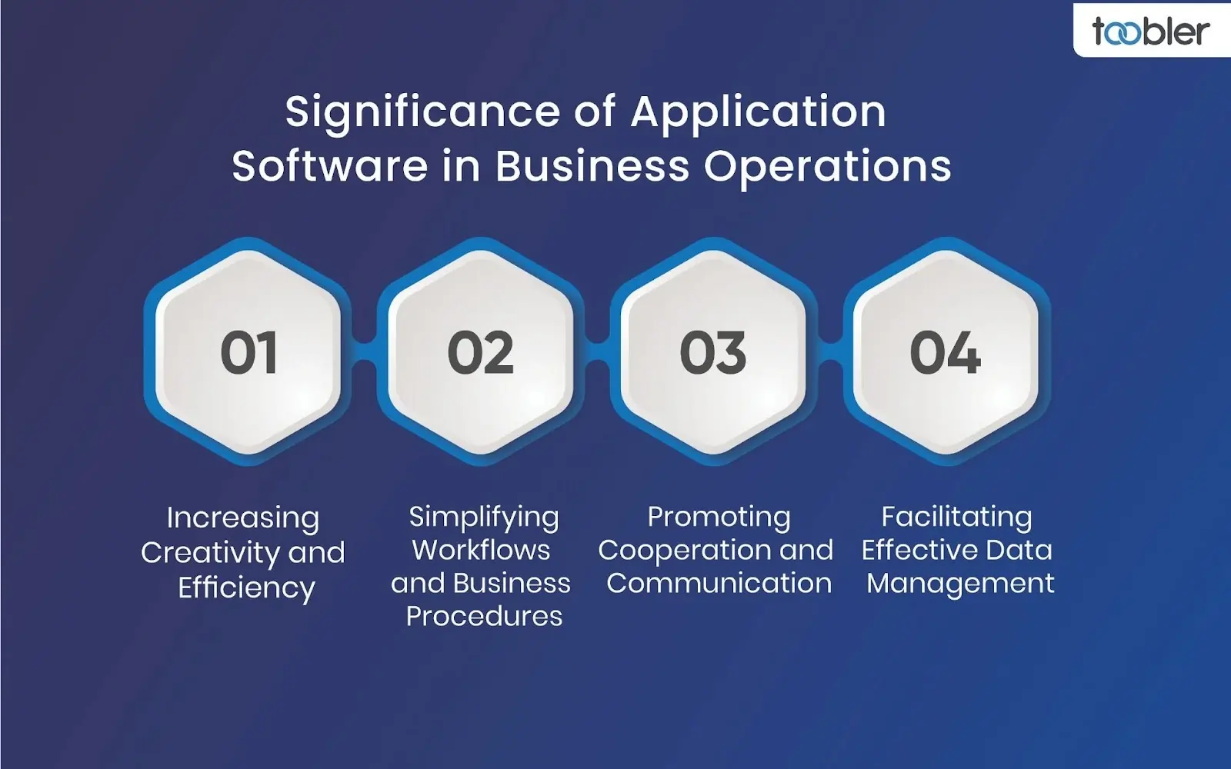

# application software in businesses:

## 1. Enhancing Efficiency and Productivity:

## [**Automation**](https://www.google.com/search?sca_esv=296ee4e81733ebef&cs=1&q=Automation&sa=X&ved=2ahUKEwi80ubAh_COAxUuxjgGHd51J44QxccNegQIERAB&mstk=AUtExfAU-Z96SHY2uOaqZWddJtkuqV9YwSiC9XEdPcJZ6E-oNZyfVlFMUlVf-8LRiVlhPfATWiwN_dzieMZflPPpKiSw9V-FcxXC2ctukNezmoVW1n9pPFkSo1vzQriwPPgi_Jo&csui=3):

Application software automates repetitive tasks, freeing up employees to focus on more strategic work. For example, accounting software automates billing and payroll, while customer relationship management (CRM) software automates tasks like lead management and email marketing.

## Workflow Optimization:

Application software can streamline business processes, making them more efficient and reducing bottlenecks. This can lead to faster turnaround times, improved service delivery, and increased productivity.

## Improved Data Management:

Applications can help businesses organize, store, and analyze data more effectively. This can lead to better decision-making, improved resource allocation, and more effective marketing strategies.

## Reduced Errors:

Automating tasks and streamlining processes can minimize the risk of human error, leading to more accurate and reliable results.

## 2. Facilitating [Collaboration](https://www.google.com/search?sca_esv=296ee4e81733ebef&cs=1&q=Collaboration&sa=X&ved=2ahUKEwi80ubAh_COAxUuxjgGHd51J44QxccNegQILxAC&mstk=AUtExfAU-Z96SHY2uOaqZWddJtkuqV9YwSiC9XEdPcJZ6E-oNZyfVlFMUlVf-8LRiVlhPfATWiwN_dzieMZflPPpKiSw9V-FcxXC2ctukNezmoVW1n9pPFkSo1vzQriwPPgi_Jo&csui=3) and Communication:

## Cloud-based Applications:

Applications like Google Drive and Microsoft Teams enable real-time collaboration among team members, regardless of location.

## Communication Tools:

Platforms like Slack and Microsoft Teams facilitate seamless communication and information sharing within the organization.

## Improved Customer Interactions:

Applications like CRM systems and helpdesk software enable businesses to manage customer interactions more effectively, providing faster and more personalized service.

## 3. Supporting Business Growth and Scalability:

## Scalability:

Application software can be scaled to accommodate growing business needs, supporting additional users, increased workloads, and new functionalities.

## Flexibility:

Businesses can choose from a wide range of applications to meet their specific needs, allowing them to adapt to changing market conditions and business requirements.

## Cost Efficiency:

By automating tasks and improving efficiency, application software can help businesses reduce operational costs and improve their bottom line.

# 4. Examples of Application Software in Business:

* Word processing and spreadsheet software: For document creation and data analysis (e.g., Microsoft Word, Excel).
* CRM systems :for managing customer relationships and interactions (e.g., Salesforce, HubSpot).
* Enterprise Re: source Planning (ERP) systems: For integrating and managing various business processes (e.g., SAP, Oracle).
* Accounting and financial software**:** For managing financial transactions and reporting (e.g., QuickBooks, Xero).
* Project management software: ). For planning, tracking, and managing projects (e.g., Asana, Jira).
* E-commerce platforms: For managing online sales and transactions (e.g., Shopify, Magento
* Marketing automation software: For automating marketing tasks and campaigns (e.g., Marketo, Pardot).

# Software development processes

The software development process, also known as the Software Development Life Cycle (SDLC), is a structured approach to designing, creating, testing, and maintaining software applications. It involves a series of defined phases, each with specific activities, to ensure the final product meets user needs and functions correctly.

## 1. Planning and Requirements Analysis:

This initial phase involves identifying the problem, defining project goals, and gathering requirements from stakeholders.

A feasibility study may be conducted to assess the project's viability.

## 2. Design:

Based on the gathered requirements, the software's architecture, user interface, and database structures are designed.

This stage may involve creating prototypes to visualize the application.

## 3. Development (Coding):

This video discusses the design phase and coding phase in detail:

The actual coding of the software takes place, with developers writing the code based on the design specifications.

This phase often involves using various programming languages and tools.

## 4. Testing:

Thorough testing is performed to identify and fix any bugs or defects in the software.

Different types of testing, such as unit testing, integration testing, and user acceptance testing, may be employed.

## 5. Deployment:

Once the software has been tested and deemed ready, it is deployed to the production environment.

This may involve installing the software on servers, configuring the environment, and making it available to users.

## 6. Maintenance:

After deployment, ongoing maintenance and support are provided to address any issues, fix bugs, and make necessary updates.

This phase ensures the software continues to function effectively and meet user needs over time.

This video explains the deployment and maintenance phase:

Several methodologies and models can be used to manage the software development process, including:

## Waterfall Model:

A sequential approach where each stage is completed before moving to the next.

Agile Development:

An iterative and incremental approach that emphasizes collaboration, flexibility, and rapid development cycles.

Spiral Model:

A risk-driven approach that involves multiple iterations of planning, design, development, and testing.

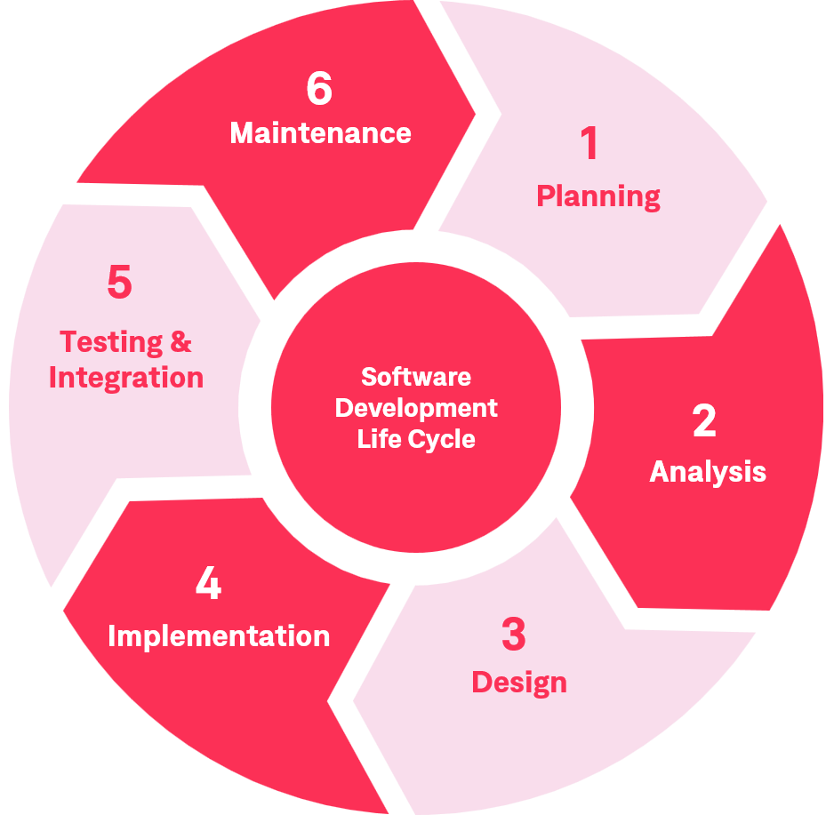

# LAB EXERCISE:

# Create a flowchart representing the Software Development Life Cycle (SDLC).

**Software Development Life Cycle (SDLC)**is a structured process that is used to design, develop, and test high-quality software. SDLC, or software development life cycle, is a methodology that defines the entire procedure of software development step-by-step. The goal of the SDLC life cycle model is to deliver high-quality, maintainable software that meets the user's requirements.

SDLC is a process followed for software building within a software organization. SDLC consists of a precise plan that describes how to develop, maintain, replace, and enhance specific software. The life cycle defines a method for improving the quality of software and the all-around development process.

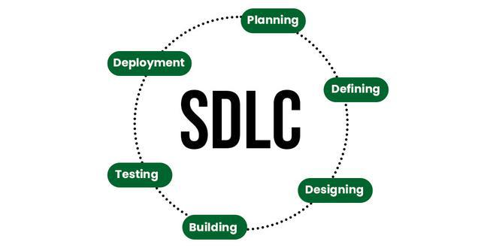SDLC

# Stages of the Software Development Life Cycle

SDLC specifies the tasks to be performed at various stages by a software engineer or developer. It ensures that the end product is able to meet the customer's expectations and fits within the overall budget. Hence, it's vital for a software developer to have prior knowledge of this software development process. SDLC is a collection of these six stages, and the stages of SDLC are as follows:

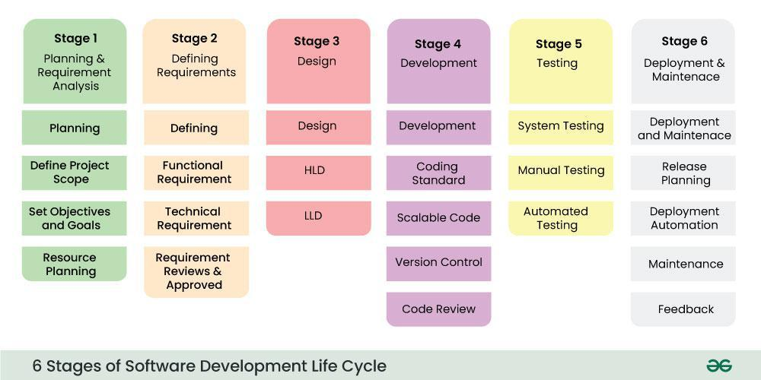

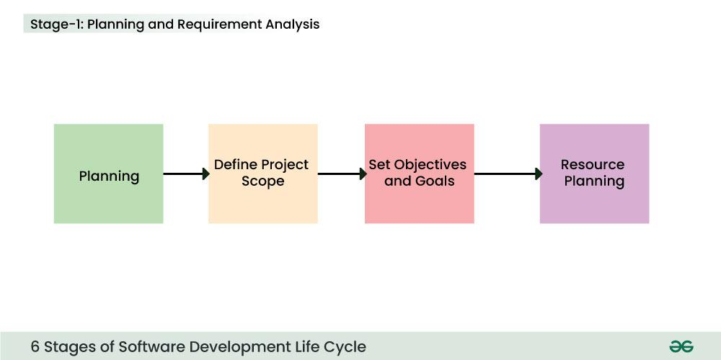

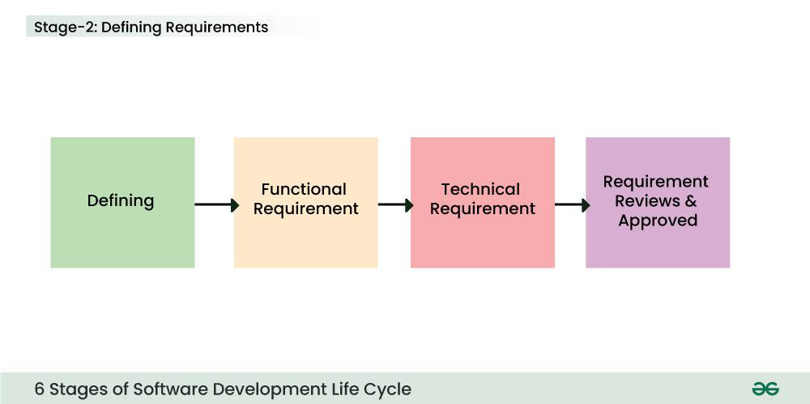

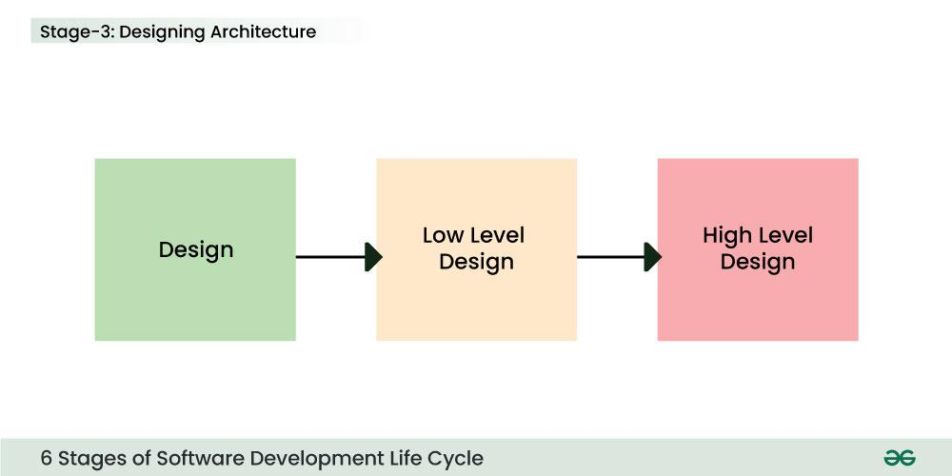

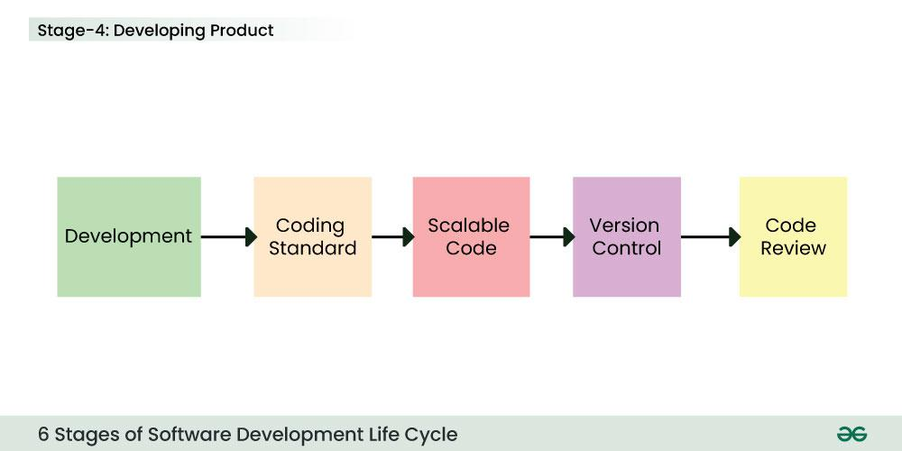

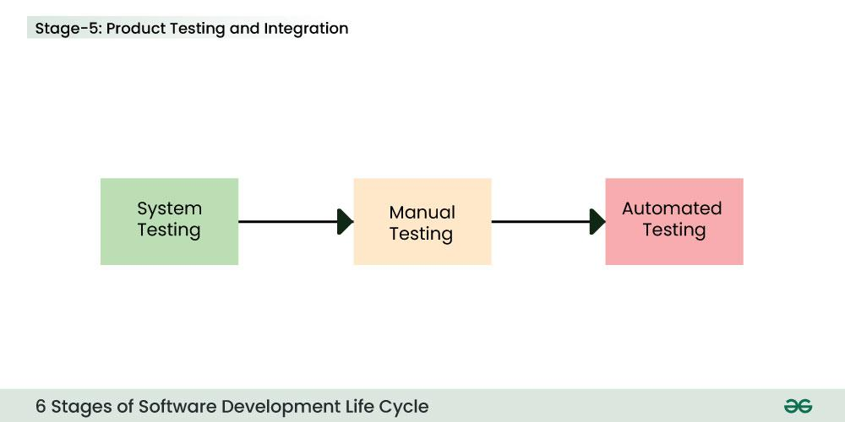Stage 5: Testing

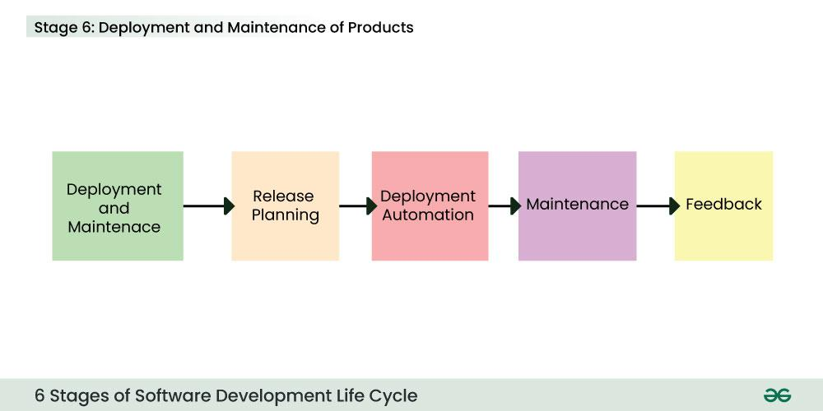

# THEORY EXERCISE:

# What are the main stages of the software development process? Software Requirement

The main stages of the software development process, often referred to as the [Software Development Life Cycle (SDLC)](https://www.google.com/search?cs=1&sca_esv=0675ce623e7febe6&q=Software+Development+Life+Cycle+%28SDLC%29&sa=X&ved=2ahUKEwjqyLHAxvCOAxUR6jgGHaoJKjQQxccNegQIAxAB&mstk=AUtExfBZtj-eBsQQ-zQdoHC0HM-MJqwJb2CfaaRTDz4chwSlTZEC707LwDRUP7sUfrgGCTCRtH79qWdkXPVEvfXPawa5F3kCOpLrJglQIt5C-zowlfmAHorzv6Bic8ycWd12VdE&csui=3), typically include planning, requirements analysis, design, development (or coding), testing, deployment, and maintenance. These phases represent a structured approach to building software, from initial concept to ongoing support.

# 1. Planning:

This initial phase involves defining the project's scope, objectives, and goals. It also includes identifying potential risks, resources needed, and creating a preliminary project plan.

# 2. Requirements Analysis:

This stage focuses on gathering and documenting the specific needs and functionalities of the software. It involves understanding user requirements, defining system requirements, and creating detailed specifications.

# 3. Design:

In this phase, the system's architecture, user interface, database structure, and overall design are determined. This stage often involves creating prototypes and models to visualize the software.

# 4. Development (Coding):

This is where the actual coding takes place, transforming the design into a functional software product. Developers write code based on the design specifications and create the software components.

# 5. Testing:

This phase involves rigorously testing the software to identify and fix bugs, ensure it meets the requirements, and performs as expected. Different types of testing, such as unit testing, integration testing, and user acceptance testing, are conducted.

# 6. Deployment:

Once the software passes all testing phases, it is deployed to the production environment, making it available for users.

# 7. Maintenance:

This ongoing phase involves providing support, fixing bugs, and making updates to the software based on user feedback and evolving needs. This ensures the software remains functional and relevant over time.

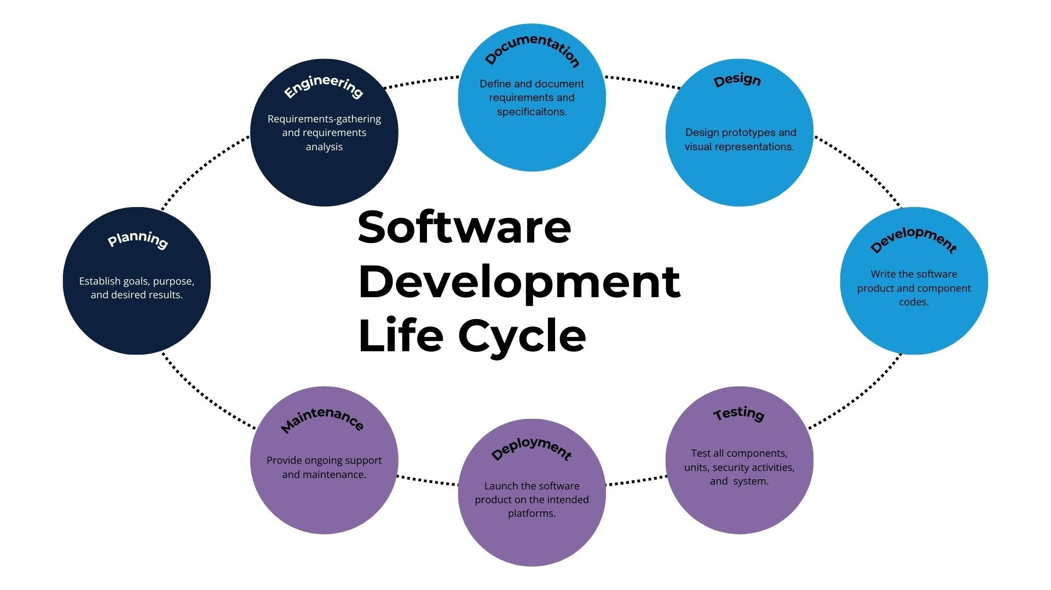

# LAB EXERCISE:

# Write a requirement specification for a simple library management system.

A requirement specification for a simple library management system is detailed below, encompassing functional and non-functional requirements.

# 1. Functional Requirements:

## Book Management:

The system shall allow librarians to add new books, including title, author, ISBN, publication year, and number of copies.

The system shall allow librarians to update existing book details.

The system shall allow librarians to delete book records.

## Member Management:

The system shall allow librarians to register new library members, including name, ID, and contact information.

The system shall allow librarians to update existing member details.

The system shall allow librarians to delete member records.

## Borrowing and Returning:

The system shall allow librarians to issue books to members.

The system shall record the borrowing date and due date for each issued book.

The system shall allow librarians to record the return of books.

The system shall calculate and display overdue fines based on predefined rules.

## Search and Reporting:

The system shall allow users to search for books by title, author, or ISBN.

The system shall display book availability status.

The system shall generate reports on borrowed books, overdue books, and member borrowing history.

# 2. Non-Functional Requirements:

## Usability:

The system shall have an intuitive and user-friendly interface.

The system shall provide clear feedback to users for all actions.

## Performance:

The system shall respond to user requests within acceptable timeframes.

The system shall handle a reasonable volume of data and transactions efficiently.

## Security:

The system shall require authentication for librarian access.

The system shall protect sensitive member and book data from unauthorized access.

## Reliability:

The system shall be stable and minimize downtime.

The system shall ensure data integrity and prevent data loss.

## Maintainability:

The system's code shall be well-structured and easily modifiable for future enhancements.

## Compatibility:

The system shall be compatible with standard operating systems and web browsers (if web-based).

# THEORY EXERCISE:

# Why is the requirement analysis phase critical in software development? Software Analysis

The requirement analysis phase is critical in software development because it lays the foundation for a successful project by clearly defining what the software should do and how it should behave. It helps avoid costly rework, misunderstandings, and ultimately, project failure by ensuring everyone involved understands the project's goals and scope.

# Defines the problem and solution

This phase helps identify the specific problems the software needs to solve and the desired solution, ensuring the software meets user needs.

# Reduces risk and rework:

By identifying potential issues early on, like conflicting requirements or infeasible features, the analysis phase helps mitigate risks and reduce the need for costly changes later in the development cycle.

# Improves communication and collaboration:

The process of gathering and documenting requirements forces stakeholders to communicate and collaborate, ensuring everyone is on the same page about the project's goals and expectations.

# Provides a clear foundation for design and development:

The requirements document serves as a blueprint for the design and development phases, guiding the team and ensuring the final product meets the specified needs.

# Ensures quality and user satisfaction:

By thoroughly understanding and addressing user needs, the requirement analysis phase contributes to the development of a high-quality product that satisfies users and meets business objectives.

# Prevents scope creep:

Clearly defined requirements help prevent the addition of unnecessary features or functionalities during the development process, which can lead to project delays and cost overruns.

# LAB EXERCISE:

# Perform a functional analysis for an online shopping system?

A functional analysis of an online shopping system identifies the specific actions or tasks the system must perform from the user's perspective. This includes tasks like product searching, adding items to a cart, managing the cart, placing an order, and making payments. For the administrator, it involves managing products, orders, users, and the overall system.

functional analysis:

# 1. User-Facing Functions:

## Product Browsing and Searching:

Search: Allow users to search for products by name, category, or keywords.

Browse: Enable users to navigate through product categories and subcategories.

Filtering: Provide options to filter products based on price, brand, size, etc.

## Product Details:

* + View Details: Display detailed information about a product, including images, descriptions, and specifications.

## Shopping Cart Management:

Add to Cart: Allow users to add selected products to their shopping cart.

View Cart: Display the contents of the shopping cart, including item details and quantities.

Update Cart: Enable users to modify the quantity of items in the cart or remove items.

Checkout: Initiate the purchase process from the shopping cart.

## User Account Management:

Registration: Allow users to create new accounts with their details.

Login: Enable users to access their accounts with their credentials.

Profile Management: Allow users to view and modify their personal information, passwords, and delivery addresses.

## Order Management:

**Place Order:** Allow users to finalize their purchase and submit the order.

View Orders: Enable users to view their order history.

## Payment Processing:

Secure Payment: Integrate with secure payment gateways to process online transactions.

Multiple Options:

**Customer Support Payment**

Contact Us: Provide a way for users to contact customer support.

FAQ: Offer a list of frequently asked questions and answers.

# 2. Administrator-Facing Functions:

## Administrator Login:

Secure login for authorized administrators.

## Product Management:

* + Add Products: Allow administrators to add new products with details, images, and pricing.
  + Edit Products: Enable administrators to modify existing product information.
  + Delete Products:  administrators to remove products from the system.
  + Manage Categories: Manage product categories and subcategories.

## Order Management: Allow

* + View Orders: Allow administrators to view all placed orders.
  + Update Order Status: Enable administrators to update the status of orders (e.g., processing, shipped, delivered).
  + Manage Order Details: Allow administrators to view and modify order details.

## User Management:

* + View Users: Allow administrators to view user accounts and their details.
  + Manage User Accounts: Enable administrators to manage user accounts (e.g., enable/disable, reset passwords).
  + Manage User Roles: Define and manage user roles and permissions.

## System Management:

* + Configuration: Allow administrators to configure system settings.
  + Analytics: Provide tools for tracking website traffic, sales, and other key metrics.
  + Security Management: Ensure the security of the system by managing user access, data encryption, and protection against common vulnerabilities.

# 3. Non-Functional Requirements:

* Security: Ensure the confidentiality, integrity, and availability of data, especially sensitive information like payment details.
* Performance: Ensure the system responds quickly and efficiently to user requests.
* Scalability: Ensure the system can handle increasing numbers of users and products.
* Availability: Ensure the system is available for users when they need it.
* Usability: Ensure the system is easy to use and navigate for all users.

Reliability: Ensure the system functions correctly and consistently.

Online Shopping Mall System Design

# THEORY EXERCISE:

# What is the role of software analysis in the development process? System Design

Software analysis is a crucial phase in the development process that involves understanding, modeling, and planning the software system before implementation. It bridges the gap between the initial requirements and the final code, ensuring the software meets stakeholder needs and is efficient, reliable, and maintainable.

role of software analysis:

# 1. Requirements Gathering and Analysis:

## Understanding Stakeholder Needs:

Software analysis begins with identifying and documenting the needs and expectations of all stakeholders (users, clients, etc.).

## Defining Requirements:

This involves clearly defining both functional requirements (what the software should do) and non-functional requirements (how it should perform, e.g., performance, security).

## Validating Requirements:

Ensuring that the gathered requirements are complete, consistent, and unambiguous.

# 2. System Design and Modeling:

[**Architectural Design**](https://www.google.com/search?sca_esv=7bb187fa02092698&cs=1&q=Architectural+Design&sa=X&ved=2ahUKEwjf-YLzz_COAxXbzjgGHTsCFEkQxccNegQIJRAB&mstk=AUtExfCVlY3HMlzWm4CPJP8XTQgTT1AwpZVQmgeiVgwIadARqMKERarGYU7o2JqTz8QsFW9hdzKTg4At0EghR4aC883VAxtF06ij-liYbonGs8d84MaKZx9gL8zacsDNBs7IelE&csui=3):

Creating a high-level blueprint of the software system, defining its major components and their interactions.

[**Detailed Design**](https://www.google.com/search?sca_esv=7bb187fa02092698&cs=1&q=Detailed+Design&sa=X&ved=2ahUKEwjf-YLzz_COAxXbzjgGHTsCFEkQxccNegQIKBAB&mstk=AUtExfCVlY3HMlzWm4CPJP8XTQgTT1AwpZVQmgeiVgwIadARqMKERarGYU7o2JqTz8QsFW9hdzKTg4At0EghR4aC883VAxtF06ij-liYbonGs8d84MaKZx9gL8zacsDNBs7IelE&csui=3):

Specifying the internal structure and behavior of each component, including data structures, algorithms, and interfaces.

Modeling Techniques:

Using various techniques like [data flow diagrams](https://www.google.com/search?sca_esv=7bb187fa02092698&cs=1&q=data+flow+diagrams&sa=X&ved=2ahUKEwjf-YLzz_COAxXbzjgGHTsCFEkQxccNegQILhAB&mstk=AUtExfCVlY3HMlzWm4CPJP8XTQgTT1AwpZVQmgeiVgwIadARqMKERarGYU7o2JqTz8QsFW9hdzKTg4At0EghR4aC883VAxtF06ij-liYbonGs8d84MaKZx9gL8zacsDNBs7IelE&csui=3), [use case diagrams](https://www.google.com/search?sca_esv=7bb187fa02092698&cs=1&q=use+case+diagrams&sa=X&ved=2ahUKEwjf-YLzz_COAxXbzjgGHTsCFEkQxccNegQILhAC&mstk=AUtExfCVlY3HMlzWm4CPJP8XTQgTT1AwpZVQmgeiVgwIadARqMKERarGYU7o2JqTz8QsFW9hdzKTg4At0EghR4aC883VAxtF06ij-liYbonGs8d84MaKZx9gL8zacsDNBs7IelE&csui=3), [class diagrams](https://www.google.com/search?sca_esv=7bb187fa02092698&cs=1&q=class+diagrams&sa=X&ved=2ahUKEwjf-YLzz_COAxXbzjgGHTsCFEkQxccNegQILhAD&mstk=AUtExfCVlY3HMlzWm4CPJP8XTQgTT1AwpZVQmgeiVgwIadARqMKERarGYU7o2JqTz8QsFW9hdzKTg4At0EghR4aC883VAxtF06ij-liYbonGs8d84MaKZx9gL8zacsDNBs7IelE&csui=3), etc., to represent the system and its behavior.

# 3. Risk Identification and Mitigation:

## Early Risk Detection:

Identifying potential risks and issues related to requirements, design, or implementation early in the process.

## Risk Mitigation Strategies:

Developing strategies to minimize or eliminate the identified risks, ensuring a smoother development process.

# 4. Ensuring Quality and Maintainability:

[**Modularity and Structure**](https://www.google.com/search?sca_esv=7bb187fa02092698&cs=1&q=Modularity+and+Structure&sa=X&ved=2ahUKEwjf-YLzz_COAxXbzjgGHTsCFEkQxccNegQIYxAB&mstk=AUtExfCVlY3HMlzWm4CPJP8XTQgTT1AwpZVQmgeiVgwIadARqMKERarGYU7o2JqTz8QsFW9hdzKTg4At0EghR4aC883VAxtF06ij-liYbonGs8d84MaKZx9gL8zacsDNBs7IelE&csui=3):

Creating a well-structured and modular design that is easier to understand, modify, and maintain.

[**Testability**](https://www.google.com/search?sca_esv=7bb187fa02092698&cs=1&q=Testability&sa=X&ved=2ahUKEwjf-YLzz_COAxXbzjgGHTsCFEkQxccNegQIZhAB&mstk=AUtExfCVlY3HMlzWm4CPJP8XTQgTT1AwpZVQmgeiVgwIadARqMKERarGYU7o2JqTz8QsFW9hdzKTg4At0EghR4aC883VAxtF06ij-liYbonGs8d84MaKZx9gL8zacsDNBs7IelE&csui=3):

Ensuring the design is testable, allowing for efficient and effective testing to verify the software's functionality.

# 5. Facilitating Communication:

## Stakeholder Communication:

Using analysis models and documentation to communicate effectively with all stakeholders, clarifying requirements and design decisions.

## Team Communication:

Providing a common understanding of the system among developers, testers, and other team members.

# LAB EXERCISE:

# Design a basic system architecture for a food delivery app.

A basic food delivery app system architecture can be designed with several key components: a [front-end](https://www.google.com/search?cs=1&sca_esv=7bb187fa02092698&q=front-end&sa=X&ved=2ahUKEwi53qDe0fCOAxXeoGMGHajSE50QxccNegQIBxAB&mstk=AUtExfCC3nFzhyWlGOSnQAoHEbtLXeriBwJVHWZlgbADY1IlY5jTAYiAPX55uCZ-n9Cc6iW-_xN7IyH1NWul73w886-9rTN0QZsEZDJVJ2qghWK8eyQjv8S9PPR1lRVFjLcNim4&csui=3) (mobile/web app), [backend services](https://www.google.com/search?cs=1&sca_esv=7bb187fa02092698&q=backend+services&sa=X&ved=2ahUKEwi53qDe0fCOAxXeoGMGHajSE50QxccNegQIBxAC&mstk=AUtExfCC3nFzhyWlGOSnQAoHEbtLXeriBwJVHWZlgbADY1IlY5jTAYiAPX55uCZ-n9Cc6iW-_xN7IyH1NWul73w886-9rTN0QZsEZDJVJ2qghWK8eyQjv8S9PPR1lRVFjLcNim4&csui=3) (including [API gateway](https://www.google.com/search?cs=1&sca_esv=7bb187fa02092698&q=API+gateway&sa=X&ved=2ahUKEwi53qDe0fCOAxXeoGMGHajSE50QxccNegQIBxAD&mstk=AUtExfCC3nFzhyWlGOSnQAoHEbtLXeriBwJVHWZlgbADY1IlY5jTAYiAPX55uCZ-n9Cc6iW-_xN7IyH1NWul73w886-9rTN0QZsEZDJVJ2qghWK8eyQjv8S9PPR1lRVFjLcNim4&csui=3)), a [database](https://www.google.com/search?cs=1&sca_esv=7bb187fa02092698&q=database&sa=X&ved=2ahUKEwi53qDe0fCOAxXeoGMGHajSE50QxccNegQIBxAE&mstk=AUtExfCC3nFzhyWlGOSnQAoHEbtLXeriBwJVHWZlgbADY1IlY5jTAYiAPX55uCZ-n9Cc6iW-_xN7IyH1NWul73w886-9rTN0QZsEZDJVJ2qghWK8eyQjv8S9PPR1lRVFjLcNim4&csui=3), and [external services](https://www.google.com/search?cs=1&sca_esv=7bb187fa02092698&q=external+services&sa=X&ved=2ahUKEwi53qDe0fCOAxXeoGMGHajSE50QxccNegQIBxAF&mstk=AUtExfCC3nFzhyWlGOSnQAoHEbtLXeriBwJVHWZlgbADY1IlY5jTAYiAPX55uCZ-n9Cc6iW-_xN7IyH1NWul73w886-9rTN0QZsEZDJVJ2qghWK8eyQjv8S9PPR1lRVFjLcNim4&csui=3) (like maps and payments). The backend would handle user authentication, order management, restaurant information, and delivery tracking. The database stores information about users, restaurants, orders, and more.

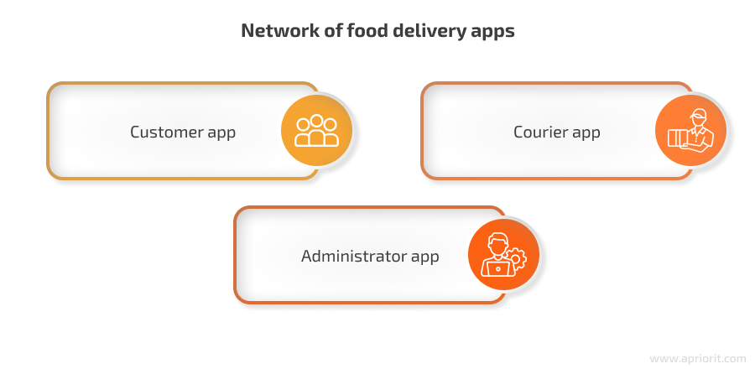

1. Core Components:

# User Service:

Handles user registration, authentication, profiles, and potentially user-specific settings.

# Restaurant Service:

Manages restaurant registration, menu items, availability, and potentially promotional offers.

# Order Service:

Manages order placement, tracking, and potentially order cancellation.

# Delivery Service:

Handles delivery driver assignments, tracking, and potentially route optimization.

# Payment Service:

Processes payments securely and handles payment-related issues.

# Notification Service:

Sends notifications to users and delivery partners via SMS, email, or push notifications.

# API Gateway:

Acts as a single entry point for all client requests, routing them to the appropriate microservices.

# Messaging Queue:

Enables asynchronous communication between services, allowing for decoupling and improved scalability.

# Database:

Stores data related to users, restaurants, orders, delivery personnel, and other relevant information.

# Tracking Engine:

Monitors order status changes in the database and updates the messaging queue for real-time tracking updates.

2. Interactions:

**Client Applications (Mobile/Web):**

Interact with the API gateway to access functionalities like browsing menus, placing orders, tracking deliveries, and managing profiles.

# Microservices:

Each service interacts with the database and potentially other services to fulfill client requests.

# External Services:

May integrate with third-party services like payment gateways, mapping providers, and geolocation services.

3. Non-Functional Requirements:

Scalability: The system should be able to handle a large number of concurrent users and orders.

Performance**:** Low latency is crucial for fast response times and a smooth user experience.

Reliability: The system should be highly available and resilient to failures.

Security: Protecting user data, especially payment information, is paramount.

Real-time Tracking: Providing accurate and up-to-the-minute delivery information is essential.

4. Database Design:

**Relational Database (e.g., PostgreSQL, MySQL):**

Suitable for structured data like user profiles, restaurant details, and order information.

**NoSQL Database (e.g., MongoDB):**

Can be used for caching and storing less structured data like user activity logs or event streams.

5. Example: Order Placement Process

A user browses restaurants and selects items to order.

The client application sends an order request to the API gateway.

The API gateway routes the request to the [Order Service](https://www.google.com/search?cs=1&sca_esv=7bb187fa02092698&q=Order+Service&sa=X&ved=2ahUKEwjG65yS0_COAxXO3TgGHeCNLksQxccNegUIngEQAQ&mstk=AUtExfAIiCXi4Sg_JPsg0fYQHasUlkHgBGCII0apODMOMKaTbHvoWLHaf6bCPEAfCZSc8pJNumDGY4tHKQIs19ypdYBcFCl0mlIXxFnqef0hH_Ia6lTK2KSXCTkrbbsNf15r8Ms&csui=3).

The Order Service validates the request and interacts with the Restaurant Service to confirm item availability.

The Order Service interacts with the Payment Service to process the payment.

Once the payment is successful, the Order Service interacts with the Delivery Service to assign a delivery partner.

The Order Service updates the database with the order details and sends a notification to the user and delivery partner.

The Tracking Engine monitors the order status and updates the messaging queue for real-time tracking updates.

The user and delivery partner can track the order progress through their respective applications.

# THEORY EXERCISE:

# What are the key elements of system design? Software Testing

The key elements of system design, particularly when considering software testing, encompass both the foundational architectural components and the specific aspects related to ensuring quality.

Key Elements of System Design:

# Architecture:

This defines the overall structure of the system, including how components interact, their responsibilities, and the underlying technologies.

# Database Design:

This involves structuring and optimizing data storage, ensuring data integrity, and efficient retrieval.

# APIs and Communication:

Defining interfaces for interaction between system components and external services, including communication protocols.

# Caching:

Implementing strategies to store frequently accessed data for faster retrieval and reduced load on primary data sources.

# Load Balancing:

Distributing incoming traffic across multiple servers to ensure system availability and performance under heavy loads.

# Security:

Designing measures to protect the system and its data from unauthorized access, attacks, and vulnerabilities.

# Scalability and Performance:

Designing the system to handle increasing user loads and data volumes efficiently while maintaining acceptable response times.

# Redundancy and Fault Tolerance:

Incorporating mechanisms to ensure system availability and data integrity even in the event of component failures.

Key Elements of Software Testing within System Design:

# Test Planning:

Defining the scope, objectives, resources, and schedule for testing activities.

# Test Case Design:

Creating specific steps and expected outcomes to verify system functionality and identify defects.

# Test Execution:

Running test cases and recording results, including any identified bugs or issues.

# Test Environment:

Establishing and configuring the necessary hardware, software, and network infrastructure for testing.

# Types of Testing:

Employing various testing methodologies such as:

Unit Testing**:** Testing individual components or modules in isolation.

Integration Testing**:** Testing the interactions between integrated components.

System Testing: Testing the complete, integrated system to verify it meets requirements.

Acceptance Testing: User-centric testing to ensure the system meets business requirements and user expectations.

Performance Testing: Evaluating system responsiveness, stability, and resource utilization under various load conditions.

Security Testing: Assessing the system's vulnerability to security threats.

# LAB EXERCISE:

# Develop test cases for a simple calculator program

Developing test cases for a simple calculator program involves verifying its core functionalities and handling edge cases.

Functional Test Cases:

Addition:

Add two positive integers (e.g., 5 + 3 = 8).

Add two negative integers (e.g., -5 + -3 = -8).

Add a positive and a negative integer (e.g., 5 + -3 = 2; -5 + 3 = -2).

Add with zero (e.g., 5 + 0 = 5; 0 + 5 = 5).

Add with decimals (e.g., 2.5 + 3.7 = 6.2).

Subtraction:

Subtract two positive integers (e.g., 8 - 3 = 5).

Subtract two negative integers (e.g., -8 - -3 = -5).

Subtract a positive and a negative integer (e.g., 8 - -3 = 11; -8 - 3 = -11).

Subtract with zero (e.g., 5 - 0 = 5; 0 - 5 = -5).

Subtract with decimals (e.g., 7.5 - 2.3 = 5.2).

Multiplication:

Multiply two positive integers (e.g., 4 * 6 = 24).

Multiply two negative integers (e.g., -4 * -6 = 24).

Multiply a positive and a negative integer (e.g., 4 * -6 = -24).

Multiply with zero (e.g., 5 * 0 = 0).

Multiply with decimals (e.g., 2.5 * 3.0 = 7.5).

Division:

Divide two positive integers (e.g., 10 / 2 = 5).

Divide two negative integers (e.g., -10 / -2 = 5).

Divide a positive by a negative integer (e.g., 10 / -2 = -5).

Divide zero by a non-zero number (e.g., 0 / 5 = 0).

Divide by zero (expected error handling, e.g., "Error: Division by zero").

Divide with decimals (e.g., 7.5 / 2.5 = 3).

# THEORY EXERCISE:

# Why is software testing important? Maintenance

Software testing is crucial for maintenance because it ensures that software remains functional, reliable, and secure after updates and modifications. Maintaining test suites through updates and addressing broken or outdated tests is essential for preventing false failures and catching real bugs, saving time and effort in the long run.

software testing is important for maintenance:

# Early Defect Detection:

Regular testing, including maintenance testing, helps identify defects early in the development cycle, preventing them from escalating into larger and more costly issues later on.

# Improved Software Quality:

By addressing issues promptly and ensuring that tests accurately reflect the current functionality, software testing contributes to a higher overall quality of the software.

# Reduced Maintenance Costs:

Catching and fixing bugs early, and maintaining test suites to accurately reflect the current state of the application, can significantly reduce the costs associated with fixing issues later in the software's lifecycle.

# Enhanced Reliability:

Well-maintained test scripts run smoothly and consistently, producing reliable results. This reliability is crucial for building trust in the software and ensuring that it behaves as expected.

# Adaptability to Change:

As software evolves and new features are added, test scripts need to be updated to reflect these changes. Maintenance testing ensures that tests remain relevant and effective, even as the software matures.

**Preventing "Test Rot":**

Without regular maintenance, test suites can become outdated and unreliable, leading to "test rot." This can result in wasted time and resources on failing tests that are not actually identifying real problems.

# Maintaining Test Suite Efficiency:

[Test maintenance](https://www.google.com/search?cs=1&sca_esv=7bb187fa02092698&q=Test+maintenance&sa=X&ved=2ahUKEwjohuew1fCOAxXhzDgGHZ-wKusQxccNegQINRAB&mstk=AUtExfDjjnf-13xd4ui3svDPXVmsdiv0ifrwTN9heOo_dyLO4jP71qR0HOrKh5jqU7Z5Y31w_WEt0N8VDIa-j79IaPPdwvczESIgoU60xk0JFeSsEtpR1MehAunmLPJcT1AHQzQ&csui=3) involves keeping test scripts up-to-date, removing outdated or redundant tests, and optimizing test execution. This ensures that the testing process remains efficient and effective.

# Supporting Future Development:

A well-maintained test suite makes it easier to add new features and functionality to the software, as the existing tests provide a solid foundation for ensuring that new changes do not introduce regressions.

# Customer Satisfaction:

By ensuring that the software is reliable and free of defects, software testing contributes to customer satisfaction.

# Security:

Software testing also plays a crucial role in identifying security vulnerabilities and ensuring that the software is protected from unauthorized access and data breaches.

# LAB EXERCISE:

# Document a real-world case where a software application required critical maintenance.

A critical software maintenance case involved a major e-commerce platform experiencing a severe security vulnerability that allowed unauthorized access to customer data

Detailed Explanation:

# 1. Discovery of the Vulnerability:

A security researcher discovered a flaw in the platform's authentication system that could allow attackers to bypass login procedures and access user accounts.

# 2. Immediate Response:

The e-commerce company immediately halted all new user registrations and transactions to prevent further exploitation of the vulnerability while a fix was developed.

# 3. Vulnerability Analysis and Fix:

Development teams worked around the clock to analyze the vulnerability, develop a patch, and test the fix thoroughly to ensure it addressed the issue without introducing new problems.

# 4. Deployment and Communication:

The patched version of the application was deployed during off-peak hours to minimize disruption. Simultaneously, the company proactively communicated the security incident to its users, explaining the issue, the steps taken to resolve it, and measures users could take to protect their accounts.

# 5. Follow-up and Monitoring:

After the deployment, the company continued to monitor the application for any unusual activity and implemented additional security measures to prevent future occurrences. This also included a review of the software development lifecycle to incorporate security best practices.

Key aspects of this maintenance process included:

[**Corrective Maintenance**](https://www.google.com/search?cs=1&sca_esv=7bb187fa02092698&q=Corrective+Maintenance&sa=X&ved=2ahUKEwjKspeM1vCOAxUTzDgGHQCeAEwQxccNegQILxAB&mstk=AUtExfBmFb22UZY6S3fSGQY1Ik5dLAN1fJQdI8soeWPaUzKJH_nTI6_3Iku5pJuzRpWSXxgg9-DpMvgYI8ZkMSPIKO9u7VseNwX_Sgxmri4P-yg6VhnS_sI70JH8VSOPpxJ-ZKU&csui=3)**:** Addressing the security vulnerability (a defect in the system).

[**Adaptive Maintenance**](https://www.google.com/search?cs=1&sca_esv=7bb187fa02092698&q=Adaptive+Maintenance&sa=X&ved=2ahUKEwjKspeM1vCOAxUTzDgGHQCeAEwQxccNegQIMxAB&mstk=AUtExfBmFb22UZY6S3fSGQY1Ik5dLAN1fJQdI8soeWPaUzKJH_nTI6_3Iku5pJuzRpWSXxgg9-DpMvgYI8ZkMSPIKO9u7VseNwX_Sgxmri4P-yg6VhnS_sI70JH8VSOPpxJ-ZKU&csui=3)**:** Implementing the fix and ensuring the application was compatible with the updated security protocols.

[**Perfective Maintenance**](https://www.google.com/search?cs=1&sca_esv=7bb187fa02092698&q=Perfective+Maintenance&sa=X&ved=2ahUKEwjKspeM1vCOAxUTzDgGHQCeAEwQxccNegQIMhAB&mstk=AUtExfBmFb22UZY6S3fSGQY1Ik5dLAN1fJQdI8soeWPaUzKJH_nTI6_3Iku5pJuzRpWSXxgg9-DpMvgYI8ZkMSPIKO9u7VseNwX_Sgxmri4P-yg6VhnS_sI70JH8VSOPpxJ-ZKU&csui=3)**:** Enhancing the application's security posture beyond the initial fix.

[**Preventive Maintenance**](https://www.google.com/search?cs=1&sca_esv=7bb187fa02092698&q=Preventive+Maintenance&sa=X&ved=2ahUKEwjKspeM1vCOAxUTzDgGHQCeAEwQxccNegQIMRAB&mstk=AUtExfBmFb22UZY6S3fSGQY1Ik5dLAN1fJQdI8soeWPaUzKJH_nTI6_3Iku5pJuzRpWSXxgg9-DpMvgYI8ZkMSPIKO9u7VseNwX_Sgxmri4P-yg6VhnS_sI70JH8VSOPpxJ-ZKU&csui=3)**:** Implementing measures to prevent similar vulnerabilities from occurring in the future.

# THEORY EXERCISE:

# What types of software maintenance are there? Development

Software maintenance can be categorized into four main types: corrective, adaptive, perfective, and preventive.

type:

**1.**[**Corrective Maintenance**](https://www.google.com/search?cs=1&sca_esv=7bb187fa02092698&q=Corrective+Maintenance&sa=X&ved=2ahUKEwix6Yze1vCOAxWVxjgGHb--BJIQxccNegQIDxAB&mstk=AUtExfDJFqjQLG3eDg9DQ5Y_MxKI5N3A-plEAascFpMZbJDROU0mfV07GGdUOKItwWiB0mr31MAqiIiuuQbhED_HeUJ2tYUDldvtgxpqp8PPhpxHMlIkeqSh-DP6rBd0l1LMzeY&csui=3)**:**

This type focuses on fixing bugs, errors, and defects that are discovered after the software is deployed. It's a reactive process aimed at restoring the software to its intended functionality.

**2.**[**Adaptive Maintenance**](https://www.google.com/search?cs=1&sca_esv=7bb187fa02092698&q=Adaptive+Maintenance&sa=X&ved=2ahUKEwix6Yze1vCOAxWVxjgGHb--BJIQxccNegQIEhAB&mstk=AUtExfDJFqjQLG3eDg9DQ5Y_MxKI5N3A-plEAascFpMZbJDROU0mfV07GGdUOKItwWiB0mr31MAqiIiuuQbhED_HeUJ2tYUDldvtgxpqp8PPhpxHMlIkeqSh-DP6rBd0l1LMzeY&csui=3)**:**

This type involves modifying the software to adapt to changes in its environment, such as updates to the operating system, hardware, or other software dependencies. It ensures the software continues to function correctly in a changing landscape.

**3.**[**Perfective Maintenance**](https://www.google.com/search?cs=1&sca_esv=7bb187fa02092698&q=Perfective+Maintenance&sa=X&ved=2ahUKEwix6Yze1vCOAxWVxjgGHb--BJIQxccNegQIEBAB&mstk=AUtExfDJFqjQLG3eDg9DQ5Y_MxKI5N3A-plEAascFpMZbJDROU0mfV07GGdUOKItwWiB0mr31MAqiIiuuQbhED_HeUJ2tYUDldvtgxpqp8PPhpxHMlIkeqSh-DP6rBd0l1LMzeY&csui=3)**:**

This type focuses on improving the software's performance, usability, or maintainability. It can involve adding new features, optimizing existing code, or enhancing user interfaces based on user feedback or evolving requirements.

**4.**[**Preventive Maintenance**](https://www.google.com/search?cs=1&sca_esv=7bb187fa02092698&q=Preventive+Maintenance&sa=X&ved=2ahUKEwix6Yze1vCOAxWVxjgGHb--BJIQxccNegQIERAB&mstk=AUtExfDJFqjQLG3eDg9DQ5Y_MxKI5N3A-plEAascFpMZbJDROU0mfV07GGdUOKItwWiB0mr31MAqiIiuuQbhED_HeUJ2tYUDldvtgxpqp8PPhpxHMlIkeqSh-DP6rBd0l1LMzeY&csui=3)**:**

This type aims to proactively identify and address potential issues before they cause problems. It can involve refactoring code, improving documentation, or optimizing performance to prevent future errors and enhance long-term stability.

# THEORY EXERCISE:

# What are the key differences between web and desktop applications? 27. Web Application

Web applications run in web browsers and don't require installation, while desktop applications are installed directly on a computer and run independently. Web applications rely on internet connectivity, while desktop applications can often function offline. Desktop applications generally offer better performance and utilize system resources more fully, while web applications are more accessible and easier to update.

# Web Applications:

Access**:** Accessed through a web browser (e.g., Chrome, Firefox, Safari).

Installation: No installation required, making them accessible from any device with a browser.

Connectivity**:** Require an internet connection to function, although some may offer limited offline capabilities.

Updates: Updates are usually centralized and applied to the server, so all users automatically get the latest version.

Performance**:** Performance can be limited by browser capabilities and internet speed.

Examples: Email clients (Gmail), social media platforms, online stores.

# Desktop Applications:

Access: Installed directly on the computer's operating system.

Installation: Must be installed on the user's computer.

Connectivity: Can often function offline, making them suitable for areas with limited or no internet access.

Updates: Updates need to be downloaded and installed individually on each computer.

Performance: Generally offer better performance and can utilize more system resources (CPU, memory, storage).

Examples**:** Word processors, video games, CAD software.

Key Differences Summarized:

|  |  |  |
| --- | --- | --- |
| Feature | Web Application | Desktop Application |
| Installation | No installation needed | Requires installation |
| Internet Dependency | Requires internet connection | Can often function offline |
| Accessibility | Accessible from any device with a browser | Accessible only on the device where installed |
| Updates | Centralized updates | Individual updates on each device |
| Performance | Can be slower due to browser limitations | Generally faster and more powerful |
| Security | Security managed by the service provider | Security relies on the user's system and the application's code |
| Cost | Often lower development and maintenance costs | Potentially higher development and maintenance costs |
| User Experience | Generally less resource-intensive | Can offer a richer and more feature-filled experience |

# THEORY EXERCISE:

# What are the advantages of using web applications over desktop applications? 28. Designing

Web applications offer several advantages over desktop applications, primarily due to their accessibility, scalability, and ease of maintenance

advantages:

# 1. Accessibility and Cross-Platform Compatibility:

Web applications are accessible from any device with a web browser and internet connection, including computers, tablets, and smartphones.

This eliminates the need for platform-specific installations and allows users to access the application from anywhere, unlike desktop applications that are tied to a specific operating system.

# 2. Scalability:

Web applications can easily scale to accommodate a growing number of users or increased data loads by leveraging cloud-based infrastructure.

This flexibility allows businesses to expand their services without significant infrastructure changes.

# 3. Automatic Updates:

Web app updates are applied on the server side, ensuring all users have access to the latest version without needing to download and install updates manually.

This simplifies maintenance and ensures users are always using the most up-to-date and secure version of the application.

# 4. Cost-Effectiveness:

Web application development can be more cost-effective than desktop application development due to lower initial development costs and easier maintenance.

Reduced hardware requirements and centralized updates further contribute to cost savings for both developers and users.

# 5. Enhanced Collaboration:

Web applications often support real-time collaboration features, allowing multiple users to work on the same project simultaneously, regardless of their location.

This can be particularly beneficial for teams working remotely or across different time zones.

# 6. Easier Distribution and Deployment:

Web applications are accessed through a web browser, eliminating the need for distribution through app stores or other complex channels.

This simplifies deployment and allows for faster updates and new feature rollouts.

# 7. Improved Security:

Web applications can incorporate advanced security measures, such as encryption and secure user authentication, to protect sensitive data.

Centralized updates also ensure that security patches are applied quickly across all users. THEORY EXERCISE:

# What role does UI/UX design play in application development? 29. Mobile Application

UI/UX design is crucial in mobile application development as it significantly impacts user engagement, satisfaction, and ultimately, the app's success. A well-designed UI/UX enhances user experience, making the app intuitive, enjoyable, and efficient to use, which can lead to increased user retention, downloads, and positive brand perception.

UI/UX design in mobile app development:

# 1. Enhancing User Experience:

## Usability:

Good UI/UX design ensures the app is easy to navigate and use, allowing users to accomplish their goals with minimal effort.

## Intuitive Navigation:

Users should be able to find what they need quickly and easily, without getting lost or frustrated.

## Efficiency:

The app should be designed to streamline user flows and optimize tasks, allowing users to accomplish their goals efficiently.

## Accessibility:

UI/UX design should consider users with disabilities, ensuring the app is usable by everyone.

# 2. Improving User Satisfaction:

## Positive First Impressions:

A visually appealing and user-friendly interface makes a positive first impression, encouraging users to explore the app further.

## Enjoyable Interaction:

A well-designed UI/UX provides a seamless and enjoyable user experience, making users want to spend more time with the app.

## Reduced Frustration:

By addressing potential pain points and providing clear feedback, UI/UX design minimizes user frustration.

# 3. Boosting User Engagement and Retention:

## Increased Time Spent:

A well-designed app keeps users engaged, encouraging them to spend more time exploring its features and content.

## Reduced App Abandonment:

**Users are more likely to stick with an app that is easy to use and provides a positive experience, reducing the likelihood of uninstalls.**

## Loyalty and Advocacy:

**Satisfied users are more likely to become loyal users and recommend the app to others.**

# 4. Providing a Competitive Advantage:

**Differentiation:**

**In a crowded app market, a well-designed UI/UX can help an app stand out from the competition.**

**Brand Building:**

**The app's design reflects the brand's identity and values, helping to build a strong brand reputation.**

# 5. Driving Business Success:

**Increased Downloads and Revenue:**

**A positive user experience can lead to increased app downloads and higher revenue through in-app purchases or subscriptions.**

**Conversion Rates:**

**Good UI/UX design can guide users towards desired actions, such as making a purchase or signing up for a service.**

**In conclusion, UI/UX design is not just about aesthetics; it's a critical factor in the success of any mobile application. By focusing on user needs and creating intuitive, engaging, and efficient interfaces, developers can create apps that users love and that drive business growth.**

# THEORY EXERCISE:

# What are the differences between native and hybrid mobile apps? 30. DFD (Data Flow Diagram)

Differences between Native and Hybrid apps

Native apps are built specifically for one operating system (iOS or Android) using that platform's native programming languages and tools, resulting in optimal performance and user experience. Hybrid apps, on the other hand, are built using web technologies like HTML, CSS, and JavaScript, and then wrapped in a native container to run on multiple platforms, often leading to slower performance and potentially limited hardware access.

Here's a more detailed breakdown:

Native Apps:

Platform Specific:

Developed using languages like Java or Kotlin for Android and Swift or Objective-C for iOS.

Performance:

Generally faster and more responsive due to direct access to the device's hardware and operating system.

User Experience:

Designed to follow platform-specific design guidelines, resulting in a more seamless and intuitive user experience [**according to Space-O Technologies**](https://www.spaceotechnologies.com/blog/native-app-vs-hybrid-app/).

Access to Hardware:

Full access to device features like camera, GPS, and sensors.

Development:

Can be more time-consuming and expensive to develop, especially for multiple platforms.

Hybrid Apps:

Cross-Platform:

Utilize web technologies (HTML, CSS, JavaScript) to create a single codebase that can run on multiple platforms.

Performance:

May be slower than native apps due to the need for a wrapper and rendering through web views.

User Experience:

Might exhibit inconsistencies in user experience across different devices or platforms.

Hardware Access:

Limited access to device features and may require plugins or workarounds.

Development:

Generally faster and more cost-effective to develop due to code reusability.

A Data Flow Diagram (DFD) is a visual representation of how data moves through a system, showing its flow from sources, through processes, to storage, and ultimately to its destinations. It focuses on the movement of data, not the sequence of actions or control flow.

Key Components of a DFD:

External Entities:

Represent the sources and destinations of data outside the system (e.g., customers, suppliers).

Processes:

Transform data within the system (e.g., calculating taxes, generating reports).

Data Stores:

Hold data for later use (e.g., databases, files).

Data Flows:

Show the movement of data between components (e.g., arrows indicating data direction).

Purpose of DFDs:

System Analysis and Design:

DFDs help analyze existing systems and design new ones by visualizing data flow.

Communication:

They provide a clear visual language for stakeholders to understand how data is handled within a system.

Problem Identification:

DFDs can highlight bottlenecks, inefficiencies, or potential issues in data flow.

Documentation:

They serve as valuable documentation for both technical and non-technical audiences.

Logical vs. Physical DFDs:

Logical DFDs focus on the logical flow of data, while physical DFDs represent the actual implementation details.

Levels of DFDs:

DFDs can be leveled to show increasing detail. A Level 0 DFD (Context Diagram) provides a high-level overview, while higher levels (e.g., Level 1, Level 2) break down processes into more granular details.

In essence, DFDs are a powerful tool for understanding, documenting, and improving how data flows within a system.

# LAB EXERCISE:

# Create a DFD for a hospital management system.

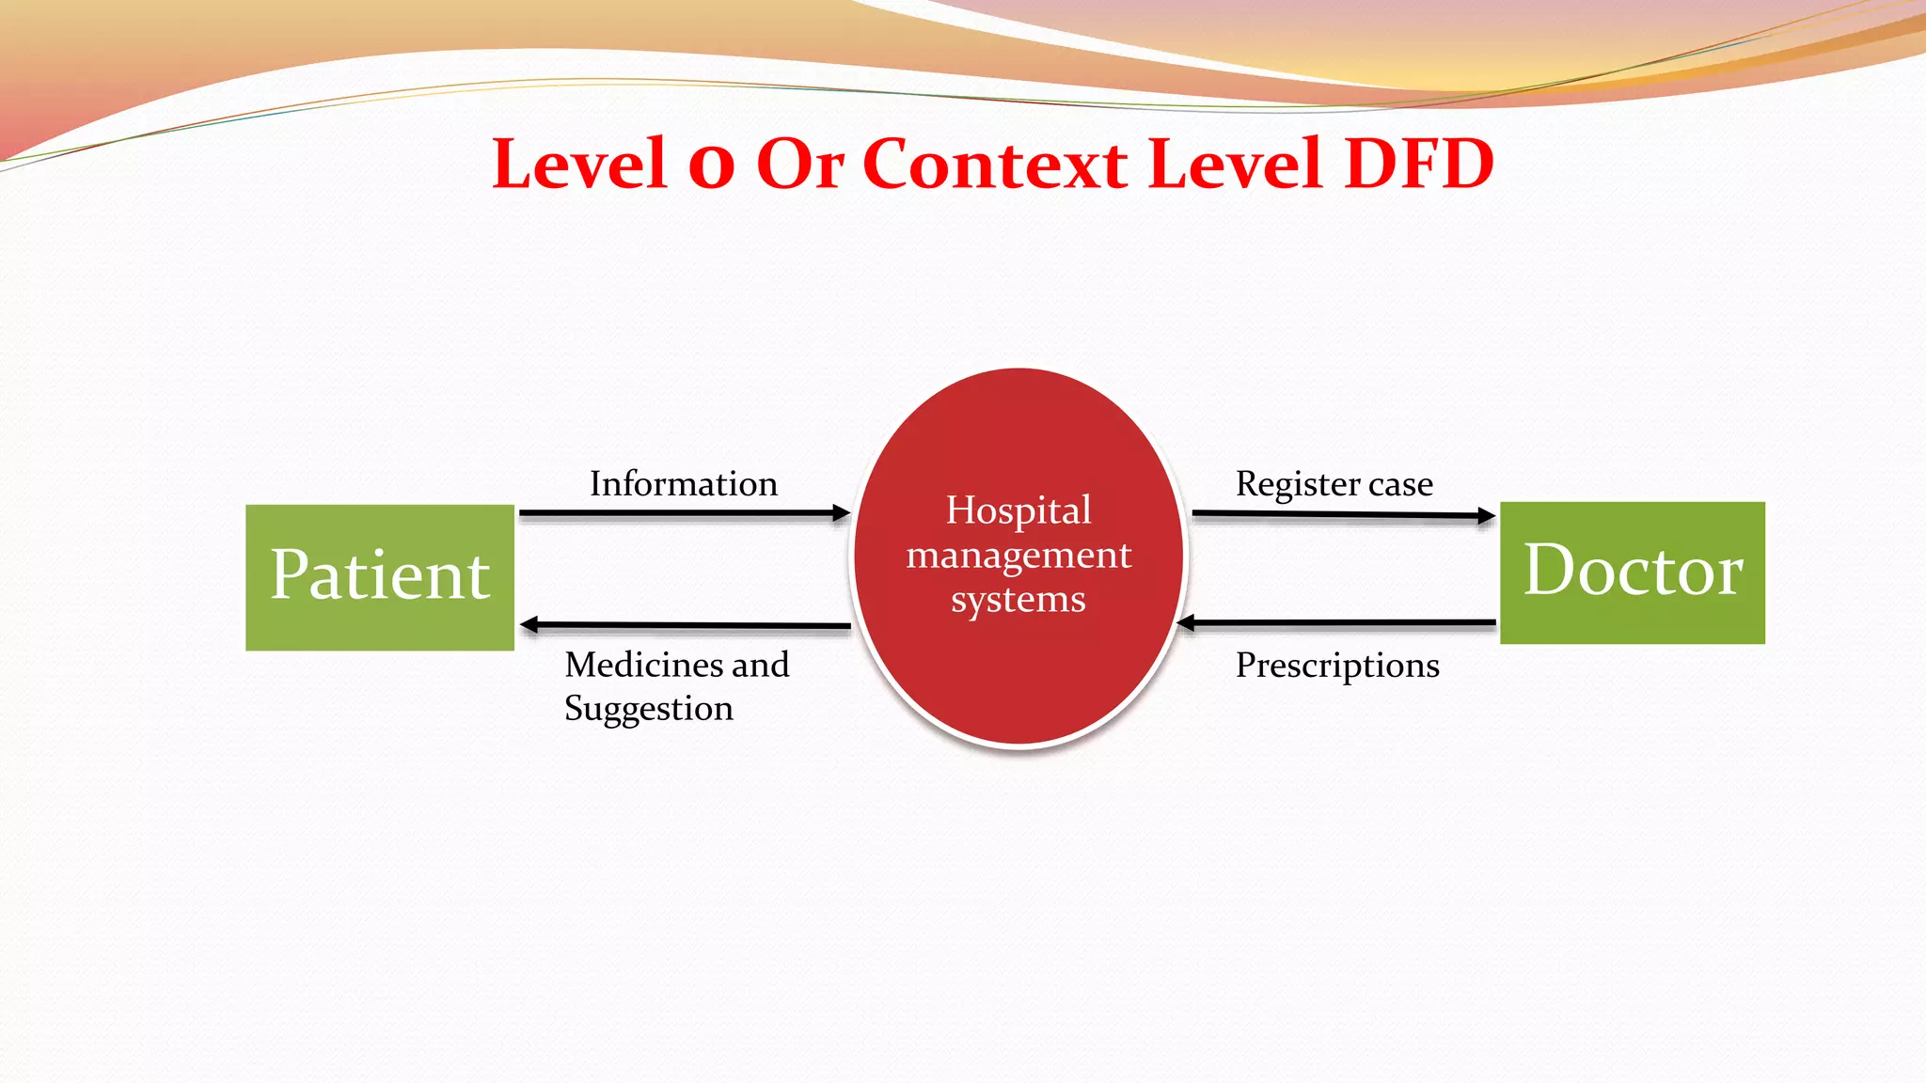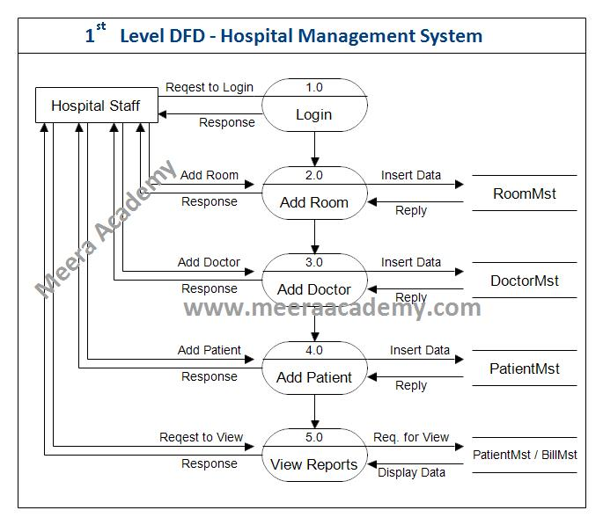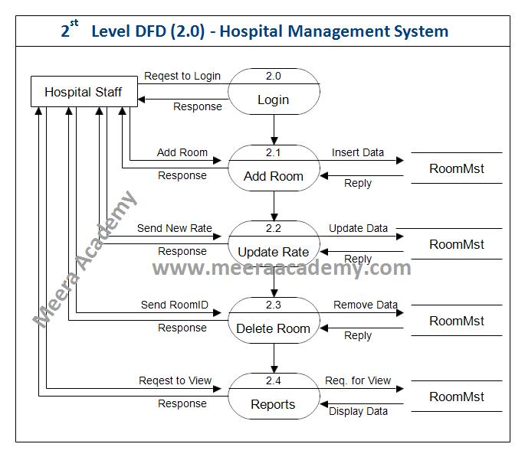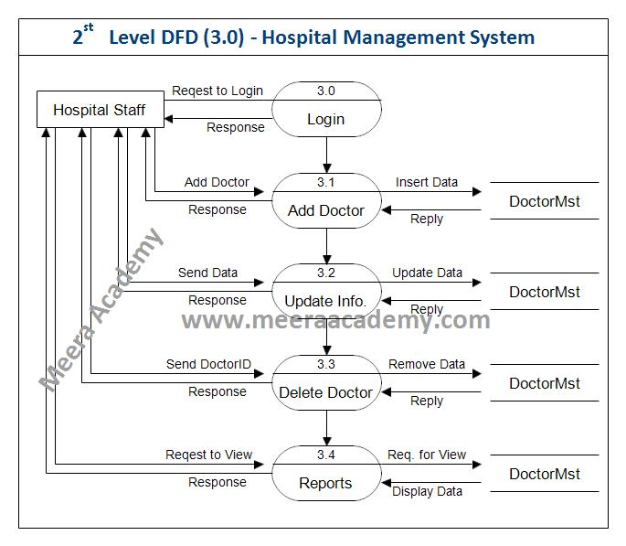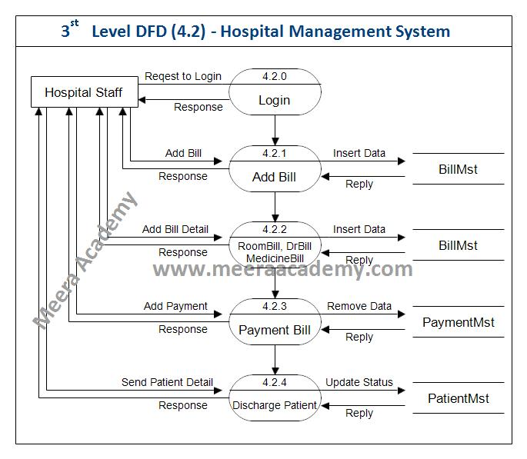

# THEORY EXERCISE:

# What is the significance of DFDs in system analysis? 31. Desktop Application

DFDs provide a clear graphical representation of a system's processes, data flows, data stores, and external entities.

A desktop application is a software program designed to run directly on a user's computer, offering specific functionalities tailored to individual tasks

# Functionality:

Desktop applications are designed for a wide range of tasks, including productivity (word processing, spreadsheets), creative work (photo and video editing), and entertainment (gaming).

# Installation:

They require installation on the user's computer and are not accessed through a web browser like web applications.

# Examples:

Common examples include web browsers (Chrome, Firefox), office suites (Microsoft Office), and specialized software like [CAD programs](https://www.google.com/search?sca_esv=5f6572bf4e7c5530&cs=1&q=CAD+programs&sa=X&ved=2ahUKEwjsyoWN4_COAxWVxjgGHb--BJIQxccNegQILxAB&mstk=AUtExfCD_65CgVzf6uxD2ZZ-2QWBCs8TEeLu5bdBSG9L8FlgaskXhR_EhVWUqgFzsjxXTJp-THA5aK8VyUOFVZS_BkJKcTy6PL0njCiH0hTI02u2QTP2fzWt21jIbTt6m4rBCic&csui=3) or [video game development tools](https://www.google.com/search?sca_esv=5f6572bf4e7c5530&cs=1&q=video+game+development+tools&sa=X&ved=2ahUKEwjsyoWN4_COAxWVxjgGHb--BJIQxccNegQILxAC&mstk=AUtExfCD_65CgVzf6uxD2ZZ-2QWBCs8TEeLu5bdBSG9L8FlgaskXhR_EhVWUqgFzsjxXTJp-THA5aK8VyUOFVZS_BkJKcTy6PL0njCiH0hTI02u2QTP2fzWt21jIbTt6m4rBCic&csui=3).

# Advantages:

Desktop applications can offer better performance, access to local resources, and more control over the user experience compared to web applications.

# .NET Desktop Runtime:

The [.NET Desktop Runtime](https://www.google.com/search?sca_esv=5f6572bf4e7c5530&cs=1&q=.NET+Desktop+Runtime&sa=X&ved=2ahUKEwjsyoWN4_COAxWVxjgGHb--BJIQxccNegQILRAB&mstk=AUtExfCD_65CgVzf6uxD2ZZ-2QWBCs8TEeLu5bdBSG9L8FlgaskXhR_EhVWUqgFzsjxXTJp-THA5aK8VyUOFVZS_BkJKcTy6PL0njCiH0hTI02u2QTP2fzWt21jIbTt6m4rBCic&csui=3) is a specific framework that allows users to run existing Windows desktop applications, [according to Microsoft](https://dotnet.microsoft.com/en-us/download/dotnet/3.1).

# [**UWP**](https://www.google.com/search?sca_esv=5f6572bf4e7c5530&cs=1&q=UWP&sa=X&ved=2ahUKEwjsyoWN4_COAxWVxjgGHb--BJIQxccNegQIHRAB&mstk=AUtExfCD_65CgVzf6uxD2ZZ-2QWBCs8TEeLu5bdBSG9L8FlgaskXhR_EhVWUqgFzsjxXTJp-THA5aK8VyUOFVZS_BkJKcTy6PL0njCiH0hTI02u2QTP2fzWt21jIbTt6m4rBCic&csui=3)**:**

The [Universal Windows Platform](https://www.google.com/search?sca_esv=5f6572bf4e7c5530&cs=1&q=Universal+Windows+Platform&sa=X&ved=2ahUKEwjsyoWN4_COAxWVxjgGHb--BJIQxccNegQIKRAB&mstk=AUtExfCD_65CgVzf6uxD2ZZ-2QWBCs8TEeLu5bdBSG9L8FlgaskXhR_EhVWUqgFzsjxXTJp-THA5aK8VyUOFVZS_BkJKcTy6PL0njCiH0hTI02u2QTP2fzWt21jIbTt6m4rBCic&csui=3) (UWP) is a framework for developing apps that work across different Windows 10 devices, including desktops, tablets, and phones.

# [**.NET MAUI**](https://www.google.com/search?sca_esv=5f6572bf4e7c5530&cs=1&q=.NET+MAUI&sa=X&ved=2ahUKEwjsyoWN4_COAxWVxjgGHb--BJIQxccNegQIHxAB&mstk=AUtExfCD_65CgVzf6uxD2ZZ-2QWBCs8TEeLu5bdBSG9L8FlgaskXhR_EhVWUqgFzsjxXTJp-THA5aK8VyUOFVZS_BkJKcTy6PL0njCiH0hTI02u2QTP2fzWt21jIbTt6m4rBCic&csui=3)**:**

.NET MAUI is a cross-platform framework that allows developers to build native mobile and desktop apps for Windows, Android, iOS, and macOS from a single codebase.

# LAB EXERCISE:

# Build a simple desktop calculator application using a GUI library.

## A simple desktop calculator application can be built using various GUI libraries,

## Project:

Create a new project or file for the calculator application.

Import the necessary modules or libraries for the chosen GUI toolkit.

## User Interface Design:

Create the main window or frame for the calculator.

Add an entry field or display area to show numbers and calculation results.

Create buttons for numbers (0-9), arithmetic operations (+, -, \*, /), a clear button, and an equals button.

Arrange the buttons and display area using layout managers (e.g., Grid, Pack, or specific layout managers provided by the library).

## Event Handling and Logic:

Implement functions to handle button clicks.

When a number button is pressed, append the digit to the display.

When an operation button is pressed, store the current number, the operation, and clear the display for the next number.

When the equals button is pressed, perform the stored operation with the current number and display the result.

Implement a clear function to reset the display and any stored values.

Include error handling for invalid operations, such as division by zero.

## Application Execution:

Initialize the GUI application.

Start the event loop to make the calculator interactive and responsive to user input.

# THEORY EXERCISE:

# What are the pros and cons of desktop applications compared to web applications? 32. Flow Chart

Desktop applications generally offer better performance, offline functionality, and richer user experiences, while web applications excel in accessibility, ease of updates, and cross-platform compatibility

# Pros and Cons

## Pros:

### Offline Functionality:

Desktop applications can operate without an internet connection, allowing users to access and work with their data even when offline.

### Enhanced Performance:

Desktop apps often provide faster performance and responsiveness due to direct access to the user's computer's resources.

### Richer User Experience:

They can offer more advanced features, immersive interfaces, and better integration with system-level functionalities.

### Greater Control and Customization:

Desktop apps provide more flexibility in terms of customization and integration with other software and hardware.

### Data Security:

Local storage can offer better control over data security and privacy, especially for sensitive information.

### Cost-Efficient:

In some cases, desktop apps can be more cost-efficient, especially when considering the costs associated with web hosting and maintenance.

Cons:

### Platform Dependency:

Desktop applications are typically tied to a specific operating system (Windows, macOS, Linux), requiring separate versions for each platform.

### Installation and Updates:

Installation can be more complex, and updates often require manual downloads and installations.

### Limited Accessibility:

Desktop apps are generally limited to the device they are installed on, unlike web apps which can be accessed from anywhere with an internet connection.

### Higher Development Costs:

Developing and maintaining desktop applications can be more expensive than web applications, especially when considering cross-platform compatibility.

# Web Applications: Pros and Cons

# Pros:

## Accessibility:

Web applications can be accessed from any device with a web browser, regardless of the operating system.

## Cross-Platform Compatibility:

Web apps work seamlessly across different platforms and devices, eliminating the need for platform-specific versions.

## Ease of Updates:

Updates are typically deployed on the server side and are automatically available to all users, simplifying maintenance.

## Cost-Effectiveness:

Web applications can be more cost-effective in terms of development, deployment, and maintenance, especially for large user bases.

## Scalability:

Web applications can easily scale to accommodate a growing number of users and data.

Cons:

## Internet Dependency:

Web applications require an internet connection to function, limiting their usability in areas with poor or no internet access.

## Performance Issues:

Web applications can be slower than desktop applications, especially for resource-intensive tasks, due to network latency and server processing time.

## Security Concerns:

Web applications are more susceptible to security threats and data breaches compared to desktop applications.

## Limited Offline Functionality:

Web applications typically lack offline functionality, although some offer limited offline capabilities through caching or syncing.

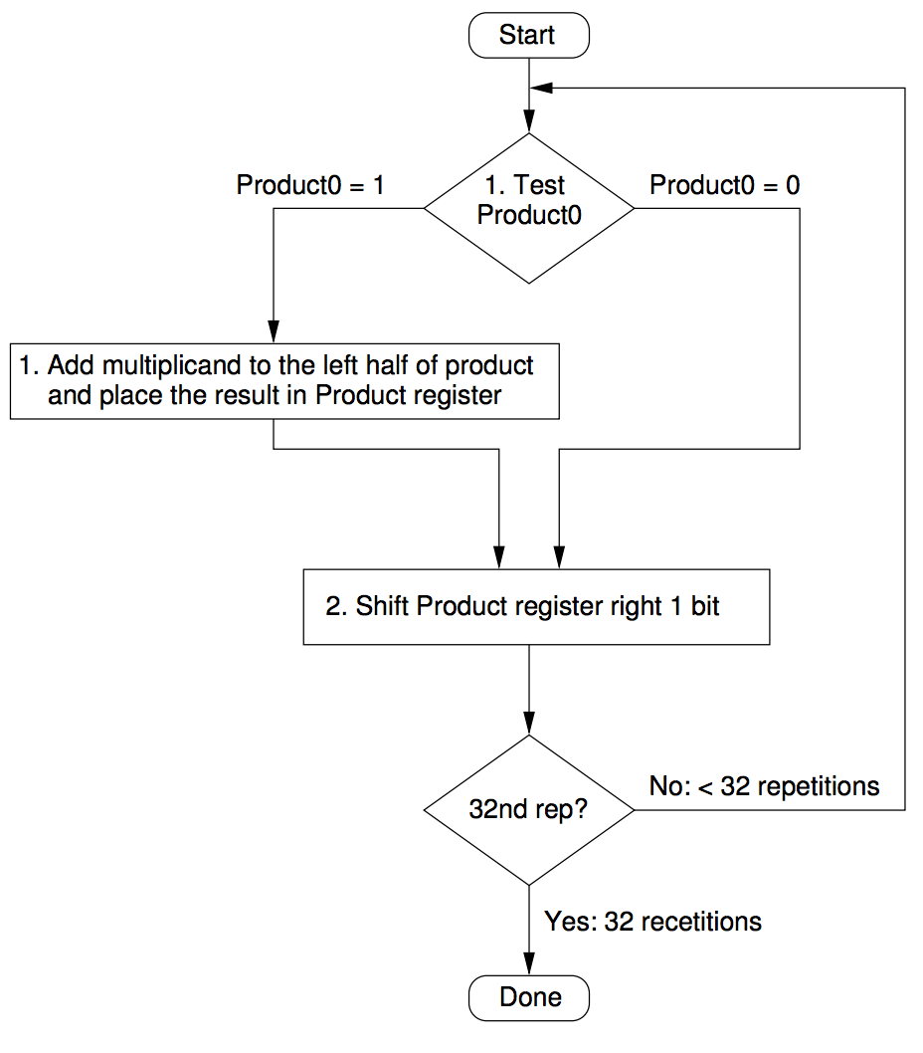

# LAB EXERCISE:

# Draw a flowchart representing the logic of a basic online registration system

start with the user accessing the registration page, then capturing user input (username, password, email, etc.), validating the data, checking for existing users, creating the new user account, and finally providing feedback to the user on the success or failure of the registration.

their representation:

## 1. Start:

The beginning of the process, usually represented by an oval shape.

## 2. Access Registration Page:

User navigates to the registration page, which is a rectangle representing a process.

## 3. Input User Data:

User enters registration details (username, password, email, etc.) which is represented by a parallelogram for input.

## 4. Validate Data:

The system checks the entered data for validity (e.g., password strength, email format). This is a decision point, represented by a diamond shape.

## 5. Is Data Valid?:

A yes/no question at the decision point.

**If Yes:** Proceed to the next step.

**If No:** Return to the "Input User Data" step to correct the errors

## 6. Check for Existing User:

The system verifies if a user with the same username/email already exists. This is a decision point, represented by a diamond shape.

## 7. Is User Exists?:

A yes/no question at the decision point.

**If Yes:** Display an error message and return to the "Input User Data" step.

**If No:** Proceed to create the account.

## 8. Create User Account:

The system creates a new user account with the provided information. This is a rectangle representing a process.

## 9. Registration Successful?:

A decision point to check if the account creation was successful.

**If Yes:** Display a success message, potentially redirecting to a login page or dashboard.

**If No:** Display an error message, possibly with details about the error.

## 10. End:

The completion of the registration process, also represented by an oval.

This flowchart provides a basic outline of the online registration process. More complex systems might include additional steps such as CAPTCHA verification, email confirmation, or multi-factor authentication.

# THEORY EXERCISE:

# How do flowcharts help in programming and system design?

Flowcharts significantly aid in programming and system design by providing a visual representation of algorithms and processes. Their benefits include:

# Clarity and Understanding:

Flowcharts offer a clear, step-by-step visual breakdown of complex logic, making it easier to understand how a program or system functions. This enhances readability and comprehension for developers and stakeholders.

# Planning and Design:

They serve as a blueprint during the design phase, allowing developers to visualize the flow of control, identify essential steps, and organize tasks chronologically before writing code. This helps in structuring the system and identifying potential issues early.

# Debugging and Error Detection:

By mapping out the program's logic, flowcharts help in identifying bottlenecks, flaws, and unnecessary steps, which can lead to more efficient and robust code. They also make the debugging process easier by providing a visual trace of the program's execution path.

# Communication and Collaboration:

Flowcharts provide a common language for discussing and sharing ideas among team members, regardless of their specific programming language knowledge. This facilitates collaboration and ensures everyone has a shared understanding of the system's design.

# Documentation and Maintenance:

They serve as valuable documentation, providing a visual record of the system's logic. This aids in future maintenance, modifications, and onboarding new team members.

# Education and Training:

Flowcharts are particularly useful for teaching programming concepts, as they visually demonstrate control structures like loops and conditionals, helping beginners grasp algorithmic thinking.